Game Engine integrates Discrete Event Simulator

By
Deepanshu Singh



Faculty of Arts and Social Sciences
University of Surrey
MSc. Business Analytics

Project Supervisor: Dr. Wolfgang Garn

September 2025

Word count: 11667

© Deepanshu Singh
Executive Summary
The GodotSim project introduces a novel approach to discrete-event simulation (DES) by integrating the SimSharp simulation engine with the Godot game engine to deliver real-time, visually immersive simulation experiences. Traditional DES platforms like Arena, SIMUL8, and AnyLogic are highly capable in terms of performance and functionality, but they often fall short in terms of intuitive visual feedback, affordability , and customizability, especially for students, independent researchers, and SMEs (Law, 2014). GodotSim addresses these limitations by enabling flexible , open-source simulations with real-time animations that are both pedagogically valuable and functionally insightful.
Throughout the project, a structured design science methodology guided the development process. Integration challenges were resolved by embedding SimSharp’s raw source files into the Godot project instead of relying on external DLLs. This decision laid the foundation for a modular, scalable system in which simulation logic (event scheduling, metric collection) operates independently of visualisation layers (UI, agent animation). Key components such as SimSharpEngine.cs, AnimationManager.cs, and CSVLogger.cs work in tandem to execute simulations, capture metrics, and present them through animated agent flows and CSV output files. The visual clarity achieved through this integration facilitates easier understanding of queuing behaviour and system dynamics.
While the current version of GodotSim is limited to M/M/1 models, its modularity makes it highly extensible. Applications range from education, where students benefit from animated, interactive representations of queueing theory, to low-cost business prototyping in service industries or logistics. The ability to configure parameters such as arrival rate, service rate, trial runs, and animation speed allows for user experimentation and real-time feedback, which is particularly valuable for decision-makers who may lack a technical background.
Performance evaluations demonstrated that GodotSim , faster than text-only simulation tools like SimPy, delivers competitive results within acceptable thresholds. Execution time is slightly higher due to the animation overhead , but this trade-off is justified by the increased interpretability and usability for non-technical users . Its real-time animated playback makes simulation outputs more engaging, especially for stakeholder presentations or training environments.
Looking ahead, GodotSim’s development can evolve in three transformative directions:
(1). Advanced Simulation Logic and Analytics: Future development should include support for multi-server queues (M/M/c) , priority queues , reneging behaviour , and customer classes. Additionally, integration of live dashboards within the Godot UI , using GDScript or C#, can offer real-time charts and analytics for key metrics like average wait time , server utilization , and throughput. Implementing this would likely take 8 -12 months for a single developer, depending on complexity and testing needs.
(2). Virtual Reality (VR) and Immersive Simulation: The Godot engine natively supports VR through the OpenXR plugin and has growing community support for XR development , (Godot Documentation, 2024). Adding VR compatibility would allow users to “enter” the simulation space, observe queue flows from different perspectives, and interact with agents and parameters using VR controllers. This immersive simulation capability is especially promising for training, education, and scenario planning. The integration of VR would require 1.5- 2.5 year of focused work by developers familiar with both Godot and XR frameworks, including testing on devices like Oculus Quest or HTC Vive.
(3). Enhanced Visualisation and 3D Environment Simulation: The current 2D animation layer can be upgraded to 3D using Godot’s built-in spatial nodes. Incorporating depth , textures, and physics-based animations will allow for more realistic environments , such as airport terminals , hospitals, or factory floors, (Godot Documentation, 2024). With support for dynamic lighting, pathfinding, and crowd simulation, Godot can become a fully-fledged 3D simulation platform. For developers familiar with Godot’s 3D pipeline , transitioning from 2D to 3D may take 10 -12 months , including asset creation and animation tuning.
Moreover , Godot’s flexibility offers a long-term strategic advantage. Unlike Unity or Unreal Engine, Godot is fully open-source and lightweight , making it ideal for academic and non-profit projects. Its C# and GDScript support lowers the barrier to entry , while the active global community ensures continued evolution and documentation. With features like scene instancing , state machines, and native support for animation trees , Godot stands out as a simulation-friendly game engine that can host both logic- driven and human- centric visual outputs.
Despite these strengths, GodotSim’s current limitations must be acknowledged. The absence of a live simulation-animation sync (animations play post-simulation), lack of error- handling for extreme parameter value-s , and the single-user design restrict usability in real-time decision-making contexts. Furthermore , the project has not yet undergone formal usability testing with target users such as educators, operations managers, or simulation professionals. Addressing these issues will require collaborative development, user feedback loops , and possibly integration with external data sources or IoT sensors to support real-world deployment.
In summary, GodotSim has proven its conceptual and functional value , showcasing that hybrid tools combining open-source simulation engines with real-time game-based visualisation can significantly enhance how DES is taught , understood, and applied. Its modular architecture, immersive visual outputs, and cost-effectiveness mark it as a viable alternative to commercial simulation platforms. The future of GodotSim lies not just in extending its simulation capabilities but in transforming it into an interactive , immersive simulation platform that leverages VR , real-time analytics, and 3D modelling to serve education, business, and public sector applications. With continued development, community engagement , and research collaboration , GodotSim could redefine simulation-based learning and decision-making for the next generation.

Declaration of Originality

This declaration must be included in your project and should be on the page immediately following the executive summary. The statement is written below and you should fill in the necessary details and make the relevant deletions:
"I hereby declare that this thesis has been composed by myself and has not been presented or accepted in any previous application for a degree. The work, of which this is a record, has been carried out by myself unless otherwise stated and where the work is mine, it reflects personal views and values. All quotations have been distinguished by quotation marks and all sources of information have been acknowledged by means of references including those of the Internet. I agree that the University has the right to submit my work to the plagiarism detection sources for originality checks."
Project Title: Game Engine integrates Discrete Event Simulator
Author's Name: Deepanshu Singh
Date: 02/09/2025

Table of Contents

Chapter 1: Introduction 1
1.1 From Simulation to Immersion: Bridging the Gap 1
1.2 Practical and Academic Motivation 2
1.3 Key Definitions and Context 3
1.4 Research Problem and Questions 4
1.5 Aim and Objectives 4
1.6 Outline of the Solution Approach 5
1.7 Contributions of the Study 5
1.8 Structure of the Dissertation 5
Chapter 2: Literature Review 6
2.1 Introduction 6
2.2 Foundations of DES and Simulation Visualisation 7
2.2.1 Discrete Event Simulation (DES): Concepts, Models, and Evolution 7
2.2.2 Simulation Visualisation: From Static Interfaces to Real-Time 3D Animation 8
2.3 Open-Source Simulation Tools 10
2.3.1 Comparative Overview of Tools 10
2.3.2 Deep Dive: SimSharp 11
2.3.3 Advantages of Open-Source Modelling 12
2.3.4.. Limitations and Gaps 12
2.4 Integration of Simulation Engines and Game Engines 13
2.4.1 Simulation Engines: Capabilities and Role in DES 13
2.4.2 Game Engines: Capabilities and Role in Visualisation 13
2.4.3 Integration Strategies in Literature 14
2.4.4 Integration Plan for This Project 14
2.4.5.. Functionality and Advantages 15
2.4.6 Comparative Summary 16
2.5 Digital Twins, Extended Reality (XR), and Real-Time Simulation 16
2.5.1 Digital Twin Concepts in Simulation 16
2.5.2 Extended Reality (XR) for Simulation Engagement 17
2.5.3.. Real-Time Simulation and Synchronisation Challenges 18
2.5.4 Advantages of Integrating Digital Twins and XR in DES 18
2.5.5.. Relevance to This Project 19
2.6 Conceptual Framework 19
2.6.1 Purpose of the Framework 19
2.6.2 Core Components from the Literature 19
2.6.3 Conceptual Framework Diagram 20
2.6.4 Alignment with Research Questions 20
2.6.5 Contribution to Methodology 21
2.7 Identified Research Gaps 21
Chapter: 3 Methodology 23
3.1 Project Background and Rationale 23
3.2 Technologies and Libraries Used 24
3.2.1 SimSharp (Simulation Engine) 25
3.2.2 Godot Engine with Mono C# Support 26
3.2.3 .NET System.IO and Diagnostics 26
3.2.4.. CSV Output and Monitors 26
3.2.5 Visualisation + Animation Framework 26
3.2.6 Modular Code Architecture 27
3.3 Simulation Architecture and Event Flow 27
3.3.1 High-Level Architecture Flow 28
3.3.2.. Simulation Event Flow in SimSharp 28
3.3.3.. Event Capture and Logging 29
3.3.4.. From Simulation to Animation 29
3.3.5 Simulation Timing vs Game Engine Clock 30
3.3.6.. Benefits of the Integrated Flow 31
3.4 Simulation Logic and Visualisation Design 31
3.4.1.. Discrete-Event Simulation with SimSharp 31
3.4.2.. Metrics Collection and Analysis 32
3.4.3 Animation Playback with Godot 33
3.4.4 Synchronising Simulation and Animation Clocks 33
3.4.5 Visual Output Example 34
3.4.6 Simulation Outputs 34
3.5 UI Interface, Control Logic, and Modular Code Architecture 35
3.5.1 User Interface and Control Logic (SimulationUI.cs) 35
3.5.2 Simulation Engine (SimSharpEngine.cs) 36
3.5.3 Event Playback and Animation (AnimationManager.cs) 37
3.5.4 Output Logging and File Management (CSVLogger.cs) 38
3.5.5.. Lessons Learned 38
Chapter 4: Result and Discussion 39
4.1. Results: 50-trial batch-clearance experiment 39
4.2. Results: 200-trial batch-clearance experiment (GodotSim vs SimPy) 42
4.3. Graphical User Interface (GUI) & Visualisation 45
4.3.1. Evaluation criteria: 45
4.4. GUI & Visualisation: 48
4.5. Features and Flexibility 48
4.5.1. Architectural openness 48
4.5.2. Modelling expressiveness 49
4.5.3. Analytics and experiment support 49
4.5.4. Interoperability and reproducibility 49
4.5.5. Ease of Use / Learning Curve 50
4.5.6. Licensing / Accessibility 50
Chapter 5: Conclusion 51
5.1 Significance and Contribution 51
5.2 Theoretical and Practical Linkages 52
5.3 Managerial Implications 52
5.4 Limitations 53
5.5 Future Work and Recommendations 53
References 54
Appendices 58
Listing: SimSharpEngine.cs 58
Lishting : SimulationUi.cs 61
Lishting : AnimationManager.cs 64
Listing: CSVLogger.cs 66
Listing: AgentEvent.cs 67
Figures 68
Figure: A1:Nodes from Main scene of GodotSim 68
Figure A3 and Figure A4: Inspector Panel to set upper and lower limit values in control 69
Figure A5: General Layout of Godot (Godotsim) 70
Figure A6: Output Summary after running simulation in Godotsim 70
Figure A7:Event Output After running Simulation in Godotsim 70

List of Tables

Table: 2.1: Open-source DES libraries developed across programming ecosystems 11
Table: 2.2: Comparative Summary of DES tools 16
Table 3.1: Scripts and Roles 29
Table 3.2: Key Simulation Elements 33
Table 3.3: What output files generates 36
Table 4.1. 50-trial comparison (batch-clearance, N=50, μ=0.8) 41
Table 4.2: 200-trial comparison (batch-clearance, N=50, μ=0.8 44
Table 4.3: Summary comparison, GodotSim, SimPy and Simul8 47

List of Figures
Figure 2.1: structured diagram illustrating the proposed framework 21
Figure: 3.1: Source Integration Success (SimSharp + Godot) 25
Figure 3.2: Library Roles & Integration Overview 26
Figure 3.3: Visual Playback Layer. (Refer to AnimationManager.cs and Figure 3.6 – Clock Synchronisation) 28
Figure 3.4: Simulation Flow Architecture 30
Figure 3.5: Event Replay Pipeline 31
Figure 3.6: Simulation Clock vs Game Engine Clock 32
Figure 3.7: Animation Frame Example 35
Figure 3.8: Wait Time Graph 36
Figure 4.1(a) Godotsim Run Time in (Ms) 50 trials graph 42
Figure 4.1(b) SimPy Run Time in (Ms) 50 trials graph 42
Figure 4.2: Simply 50 trials result 42
Figure 4.3: Godotsim 50 trials result 43
Figure 4.4 (a) Godotsim Run Time in (Ms) 200 trials graph 45
Figure 4.4 (b) SimPy Run Time in (Ms) 200 trials graph 45
Figure 4.5: Simpy 200 trials 45
Figure 4.6: Godotsim 200 trials 46
Figure 4.7: GodotSim UI (Start/Stop, speed slider) + frame from animation with labels “arrival”, “queueing”, “service”, “exit”. 48
Figure 4.8: GodotSim visual playback with overlays: queue length, utilization, and a callout on the longest wait case. 49
Figure 4.9: SimPy analytics: waiting-time histogram and SIMUL8 dashboard 49

Chapter 1: Introduction
This chapter introduces the research context, motivation , and objectives for the study. It begins with an overview of the importance of discrete event simulation (DES) in business and industrial applications , then narrows to the limitations of current DES tools and the opportunities presented by immersive visualisation through game engines . The chapter outlines both the practical and academic motivations for the research , provides key definitions, and states the research problem and questions. The aim and objectives of the research are then presented, followed by an outline of the solution approach, expected contributions, and the structure of the dissertation.

1.1 From Simulation to Immersion: Bridging the Gap
Discrete Event Simulation (DES) is a computational modelling technique in which the state of a system changes at discrete points in simulated time, triggered by specific events (Sayama, 2015, p. 11). It allows analysts to evaluate system performance under different configurations, test improvement strategies, and analyse complex interactions without disrupting actual operations (Rossetti, 2020, Ch. 1). DES has been widely applied in domains such as manufacturing, logistics, healthcare, and service management.
Despite its proven analytical value, traditional DES tools often have limited visualisation capabilities. Commercial platforms such as Arena, Simio, and Simul8 typically employ schematic 2D interfaces or basic 3D renderings. While these formats are adequate for trained analysts, they can be challenging for non-technical stakeholders to interpret, reducing their effectiveness for communication and decision-making (Turner & Garn, 2022, p. 3).
Conversely, modern game engines such as Unity and Godot provide sophisticated 3D rendering, interactive user interfaces, and real-time responsiveness (Godot Documentation, 2024, “Scripting in C#”). These strengths position them as promising platforms for simulation visualisation, yet they lack the built-in event scheduling and process modelling capabilities of DES systems (Pernas-Álvarez & Crespo-Pereira, 2024, pp. 2–4).
This research bridges that gap by developing GodotSim, a modular platform that integrates Sim#, an open-source DES library in C#, with the Godot game engine. The integration adopts a replay-based approach, in which simulation events are recorded during execution and later animated in Godot. This separation of simulation logic from visualisation aims to combine DES analytical accuracy with immersive, accessible presentation.

1.2 Practical and Academic Motivation
Practical Motivation
In real-world operations, the consumers of simulation outputs are often not simulation specialists. Managers, operators, and trainees may need to understand system behaviour and performance changes without interpreting raw statistics or technical charts. Immersive simulation, in which animated agents represent entities moving through a process, can make complex system dynamics clearer and more engaging, supporting training, communication, and decision-making (Rehman & Kim, 2024, p. 7).
A second practical driver is accessibility. Many high-fidelity DES tools are commercial products with substantial licensing costs, limiting availability for smaller enterprises, educational contexts, or open collaborative development. GodotSim, being fully open-source, offers a no-cost, extensible alternative that can be adapted for a range of business and educational needs.
Academic Motivation
From a scholarly perspective, recent literature emphasises the need for human-centric simulation systems that separate the simulation execution from the interaction and decision-support layers, enabling greater flexibility and usability (Turner & Garn, 2022, p. 3). Research such as Pernas-Álvarez & Crespo-Pereira (2024, pp. 5–7) has demonstrated that modular integration between DES engines and game engines (in their case, Unity) can deliver interactive, real-time simulations that improve user engagement.
However, most such work focuses exclusively on Unity, leaving the capabilities of Godot, an open-source and C#-compatible alternative, largely unexplored in academic literature. Furthermore, few studies explicitly adopt a replay-based event animation architecture, in which simulation events are logged and later rendered independently of the execution engine. This research addresses both gaps, contributing a new example of lightweight, modular DES game engine integration.

1.3 Key Definitions and Context
- Discrete Event Simulation (DES) : A modelling approach where the system state changes only at discrete time points when specific events occur (Sayama, 2015, p. 11; Rossetti, 2020, Ch. 1).
- Queuing System : The mathematical study of waiting lines, focusing on how entities arrive, wait for service , and depart after being served. It models the relationships between arrival rates, service rates, number of servers, and system capacity to predict measures such as average waiting time, queue length, and server utilisation (Garn, 2018, pp. 170–176). Models are often expressed using Kendall’s notation (e.g., M/M/1), which specifies the arrival process, service process, and number of servers (Garn, 2018, p. 174). Stability is a core concept: a stable system has a service rate exceeding its arrival rate, preventing queues from growing indefinitely; an unstable system has demand exceeding capacity, leading to unbounded queues (Garn, 2018, p. 173).
- Sim#: An open-source DES library written in C# . Based on the SimPy paradigm , it supports process- oriented modelling, event scheduling, and queueing system simulation (Heil, Krause, & Meyer, 2020, pp. 1–2).
- Godot : An open-source, cross- platform game engine supporting 2D and 3D graphics, animation, and scripting in C#. It employs a modular, scene –node architecture for building interactive applications (Godot Documentation, 2024, “Scripting in C#”).
- Modular Simulation Architecture: A system design approach that separates simulation execution from visualisation, enabling independent development, testing, and modification of each layer (Pernas-Álvarez & Crespo-Pereira, 2024, pp. 5–7).
- Replay-Based Visualisation: A method in which simulation events are recorded with timestamps during execution and later replayed as animations. This decouples simulation from visualisation, improving performance and allowing multiple visualisations from a single simulation run (Turner & Garn, 2022, p. 3).

1.4 Research Problem and Questions
While DES and game engine technologies have matured individually, their integration remains rare, especially within open-source, C#-based environments. Existing DES tools often lack immersive visualisation, while game engines lack process simulation capabilities. Bridging this divide requires a modular architecture that leverages the strengths of both.
Central Research Question:
Why is it important to integrate discrete event simulation with immersive visualisation platforms like game engines, and how can such integration be practically achieved using Sim# and Godot?
Supporting Research Questions:
1). What are the limitations of current DES tools in visualisation, usability, and accessibility?
2). How can Sim# and Godot be modularly integrated to support both simulation logic execution and visual feedback?
3). How does the proposed system compare with existing DES tools in performance, usability, and visual clarity?
4). What are the potential business and educational applications of immersive DES tools?

1.5 Aim and Objectives
Aim: To develop and evaluate a modular discrete event simulation platform that integrates Sim# with the Godot game engine for immersive, replay-based visualisation.
Objectives:
1). To review existing DES platforms and immersive simulation research.
2). To implement an M/M/1 queueing model in Sim#, logging each simulation event with a timestamp.
3). To develop a Godot-based visualisation engine that replays these events in 2D/3D environments.
4). To integrate interactive features such as UI controls, simulation speed adjustment, and trial run selection.
5). To evaluate the platform on system performance, visual clarity, and user experience.
6). To explore opportunities for VR integration and GUI-based model building.

1.6 Outline of the Solution Approach
This research adopts a quantitative system development methodology. The simulation logic will be implemented in Sim#, executing the M/M/1 model and recording events such as arrivals, queue entries, service starts, and exits. These events will be stored in a structured log with timestamps. The Godot engine will then read the event log and animate the process flow, rendering agents in real time within a chosen scene. By decoupling simulation execution from visualisation, the system supports flexible animation, reduced computational overhead, and the potential for multiple visual outputs from a single simulation run.

1.7 Contributions of the Study
This research makes the following contributions:
a). Technical: Development of GodotSim, the first documented open-source integration of Sim# and Godot for DES visualisation.
b). Methodological: Introduction of a replay-based modular architecture that separates simulation execution from visualisation.
c). Practical: Provision of a no-cost, extensible simulation platform suitable for SMEs, educational institutions, and researchers.
d). Academic: Empirical evidence of an underexplored integration pathway in immersive simulation research, contributing to the field of human-centric simulation design.

1.8 Structure of the Dissertation
The dissertation is structured as follows:
Chapter 1: Introduction , Context, motivation, research gap, questions, aim, and structure.
Chapter 2: Reviews literature on DES theory, queueing systems, open-source simulation tools, immersive technologies, and game engine integrations, identifying gaps in current research.
Chapter 3: Outlines the methodology, detailing the architectural design, development process, and evaluation metrics.
Chapter 4: Presents the implementation of GodotSim, covering the Sim# model, event logging and Godot integration and Evaluates performance and usability, comparing results with existing DES platforms
Chapter 5: Concludes with the main findings, contributions, limitations, and recommendations for future work

Chapter 2: Literature Review

2.1 Introduction
The purpose of this chapter is to provide a critical and structured review of existing literature relevant to the development of a modular, open-source discrete event simulation (DES) system integrated with real-time visualisation using the Godot game engine. Rooted in the research aim to explore how simulation engines like SimSharp can be combined with game engine technologies for immersive, explainable, and user-centric DES experiences, this literature review lays the academic and technical foundation necessary to address the research questions and objectives outlined in Chapter 1.
This review investigates three interconnected domains: the theoretical principles of DES and queueing models; the capabilities and limitations of open-source simulation tools; and the emerging role of game engines in enhancing the accessibility, visualisation, and interactivity of simulation outputs. As the project seeks to contribute both practically by developing a working integration and academically by addressing gaps in current open-source DES-visualisation research the literature review also draws on recent industry studies, academic experiments, and simulation architecture frameworks.
The scope of this chapter is not limited to technical comparisons of simulation libraries or rendering tools. It critically examines conceptual frameworks for integrating simulation and visualisation, explores digital twin architectures, and considers the influence of extended reality (XR), hybrid modelling, and explainable AI (XAI) in simulation design. Given the interdisciplinary nature of the topic, the review incorporates sources from operations research, computer science, industrial engineering, and simulation modelling literature.
To maintain coherence and analytical depth, the literature is reviewed thematically following the CDRG framework: Compare, Define, Review, and Gap identification. Each theme focuses on key components that inform the development of this dissertation’s simulation platform, with emphasis on academic relevance, technical feasibility, and human-centric simulation design.
By the end of this review, a clear theoretical and practical rationale will emerge for implementing a simulation system that combines SimSharp’s event-driven modelling capabilities with Godot’s interactive visualisation potential bridging an identified gap in open, immersive DES research and contributing to the discourse on simulation explainability and usability in modern systems engineering.

2.2 Foundations of DES and Simulation Visualisation

2.2.1 Discrete Event Simulation (DES): Concepts, Models, and Evolution
Discrete Event Simulation (DES) is a computational modelling approach used to represent systems where state transitions occur at discrete points in time, driven by the occurrence of specific events such as arrivals, services, or departures (Rossetti, 2021). Each event marks a change in system status, and time progresses only when such events are executed. This makes DES especially suitable for analysing stochastic systems in logistics, manufacturing, healthcare, and telecommunications, where randomness, queues, and delays are inherent.
As defined by (Garn, 2018), DES is a stochastic, process-driven simulation method that models individual entity flows, resource allocations, and queueing behaviours over time. It provides insights into system performance, bottlenecks, and utilisation, without the need to interfere with real-world operations. DES models rely on the construction of event calendars, where future events are scheduled and executed in sequence this underpins tools like SimPy, Arena, and SimSharp.
A fundamental principle in DES is Little’s Law, which states:
L= λW
Where: L is the long-run average number of items in the system, λ is the long-run average arrival rate, W is the average time an item spends in the system.
This identity, formally proven by John D.C. Little, provides a foundation for performance analysis in queueing systems and applies to both open and closed systems under steady-state conditions (Little, 1961; Garn, 2018, pp. 172–182).
To formalise queuing behaviour in DES, Kendall’s notation is frequently used. An M/M/1 system, for example, represents:
M: Memoryless (exponential) interarrival time, M: Memoryless service time, 1: One server.
Such models assume Poisson arrivals and exponential service times conditions often met in real-world systems like customer service desks, bank queues, or call centres. SimSharp provides built-in constructs to simulate these configurations, allowing for customisation of interarrival and service distributions, queue discipline, and resource constraints (Heil et al., 2020).
Historically, DES was implemented in batch-processing environments using languages like SIMULA or GPSS. With the advent of GUI-based commercial tools such as Arena, Simul8, and Witness, DES became more accessible to non-programmers (Swain, 2013). However, these tools often hide internal logic, limit extensibility, and are constrained by licensing motivating the rise of open-source alternatives like SimPy (Python), Ciw (Python), and SimSharp (C#) (Palmer et al., 2019).
Modern DES frameworks, including SimSharp, allow developers to build modular and reusable simulation components using object-oriented programming, while still adhering to the discrete-event scheduling paradigm. These libraries also support advanced features such as preemptive resource handling, conditional waits, event cancellation, and multi-class entities (Heil et al., 2020).
Despite these advances, the literature has highlighted a critical gap: the visualisation of DES remains underdeveloped. Most simulation outputs are presented as charts, logs, or static animations, which may limit stakeholder engagement and system understanding (Turner & Garn, 2022). This leads to the next crucial development enhanced simulation visualisation.

2.2.2 Simulation Visualisation: From Static Interfaces to Real-Time 3D Animation
Visualisation plays a central role in simulation communication. As systems become more complex, static reports and queue plots no longer suffice. Stakeholders, including managers, engineers, and policy-makers, increasingly expect intuitive, real-time representations of system behaviour to support better decision-making (Millington, 2010; Eberly, 2007).
Early DES visualisation relied on simple 2D diagrams showing entity movement between queues and servers. While sufficient for technical validation, these representations lacked the richness needed for education, training, or operational use. As a result, simulation developers began embedding animation layers into DES tools. Commercial packages like AnyLogic and Simio offer 3D visualisation modules, but they are proprietary and often cost-prohibitive (Dias et al., 2016).
Game engines, such as Unity, Unreal Engine, and Godot have emerged as viable alternatives. Originally built for video games, these engines offer real-time rendering, physics engines, camera controls, and interaction scripting. This opens new possibilities for simulation developers to create immersive and explainable visualisation environments (Pernas-Álvarez & Crespo-Pereira, 2024).
Among game engines, Godot stands out for its open-source license, lightweight footprint, and native C# support, making it highly compatible with SimSharp. Godot’s node-based scene system allows agents, environments, and animations to be constructed with modularity and reusability. Its animation player and tween nodes can interpolate movement between positions, enabling smooth visual representation of agent flows in DES models (Godot Documentation, 2024).
However, a key architectural challenge persists: game engines operate on frame-based, real-time clocks, whereas DES operates on discrete event-based time (Fumarola et al., 2010). This mismatch complicates real-time integration, especially when attempting to visualise long-running simulations at fixed frame rates.
(Turner and Garn, 2022) propose a replay architecture to address this challenge. In such a model, simulation events are executed first and logged with timestamps. The visualisation engine then replays these events using animations and delays calibrated to the original simulation timing. This decouples the simulation logic from rendering concerns and ensures accuracy and repeatability.
This dissertation builds upon that principle: using SimSharp to generate a full event log of arrivals, queue entries, service start, and departures, and then replaying these events inside the Godot engine with agent animations. This not only enhances clarity but also opens the door to explainable visualisations, where users can visually trace decisions and delays in the system an essential component of human-centric simulation systems.
As industries shift toward digital twins and extended reality (XR), visualisation is no longer a secondary concern, it is central to simulation effectiveness (Turner & Garn, 2022; Journal of Industrial Information Integration, 2023). The foundation laid in this section supports the technical architecture and design decisions in this research project, enabling a seamless integration of simulation analytics and 3D visual feedback.

2.3 Open-Source Simulation Tools
This section focuses on reviewing key open-source DES libraries, with emphasis on SimSharp, and builds a critical understanding of their strengths, limitations, and suitability for integration with game engines like Godot. It presents comparisons with other tools, highlighting architectural differences and gaps that justify this dissertation’s direction.
The adoption of open-source simulation frameworks has significantly accelerated in both academic and applied research contexts, driven by the need for flexibility, reproducibility, and cost-efficiency (Dagkakis & Heavey, 2016). Unlike proprietary tools such as Arena, Simio, or Witness, often criticised for black-box modelling and high licensing costs, open-source libraries offer transparency, extensibility, and compatibility with modern development environments (Dias et al., 2016; Rossetti, 2021). These tools are particularly relevant in a time where customisation, integration with other software components, and the need for fine-grained control over logic and data pipelines are critical.

2.3.1 Comparative Overview of Tools
Multiple open-source DES libraries have been developed across programming ecosystems:
Library | Language | Key Features | Notable Limitations | Source
SimPy | Python | Coroutine-based, easy to learn, wide adoption | Not suitable for real-time animation | Law & Kelton (2014); Rossetti (2021)
SimJulia | Julia | Based on SimPy, high-performance computing support | Niche community, limited documentation | Dagkakis & Heavey (2016)
DESMO-J | Java | Object-oriented, detailed statistics, event tracing | Verbose syntax, not designed for visualisation | Palmer et al. (2019)
Ciw | Python | Focus on reproducibility, blocking & baulking | Python-based, no direct C# integration | Palmer et al. (2019)
SimSharp | C# | Coroutine-based, flexible, .NET compatible | Limited GUI or visualisation support | Heil et al. (2020); GitHub, 2025
Table: 2.1: Open-source DES libraries developed across programming ecosystems

SimPy and Ciw have become standard choices in Python environments. SimPy is praised for its intuitive coroutine system and has been used in many educational and industrial modelling projects. However, its Python foundation limits performance and direct compatibility with game engines like Godot or Unity, which rely on C# or C++ for tight integration (Godot Documentation, 2024; Unity Docs, 2024).
In contrast, SimSharp is written in C# and is designed to mirror SimPy’s coroutine model while being fully compatible with the .NET ecosystem. This makes it highly suitable for integration with C#-friendly engines such as Godot and Unity. Despite its technical strengths, SimSharp remains underutilised in academic literature, an important gap this dissertation addresses.

2.3.2 Deep Dive: SimSharp
SimSharp, developed by (Heil, Krause, and Meyer, 2020), is an open-source, process-based DES library designed for flexibility and modularity. It implements generator-based coroutines using IEnumerable<Event>, allowing event sequencing, resource management, and priority handling with minimal overhead.
Key technical features include: (a) Preemptive resources and interrupt handling. (b) Conditional wait events and timeouts. (c) Priority queues using a high-speed C# implementation (BlueRaja, 2024). (d) Simple API design for reusable process logic. (e) Discrete-time event scheduling through a simulation environment object.
The core simulation loop in SimSharp is efficient and well-suited to modelling M/M/1, M/M/c, and custom queueing systems. Sample models available in Heal research’s GitHub repository (Heil et al., 2020 ), include: (a) MM1Queueing.cs : a basic server with exponential interarrival and service time.
(b). BankRenege.cs : customers leaving after timeout while waiting. (c) InventoryControl.cs: periodic restocking with conditional triggers.
From a modelling standpoint, SimSharp offers fine control over process interactions, which is especially valuable in service-based systems where queue disciplines, reneging, or blocking are critical design factors (Heil et al., 2020; Garn, 2018).
Crucially, SimSharp aligns well with Godot’s scripting environment. Both use C#, enabling shared logic components and easy data interchange. This makes SimSharp an ideal simulation engine for event-driven systems where visual feedback is managed separately by the rendering layer.

2.3.3 Advantages of Open-Source Modelling
(Palmer et al. 2019) argue that open-source simulation libraries promote better scientific practices, particularly in academic contexts where transparency, replicability, and peer review are essential. Additionally, (Dagkakis and Heavey, 2016) found that open-source tools outperform commercial software in situations where custom metrics, unusual system logic, or real-time data integration are required.
Further advantages include: (a) Auditability: All modelling logic is visible and inspectable (Rossetti, 2021). (b) Extensibility: Simulation logic can be extended using any .NET or game engine API (Garn, 2018). (c) Cost-efficiency: No license costs allow adoption in education and SMEs (Dias et al., 2016). (d) Integration: APIs and modular components support interoperation with databases, IoT devices, or 3D engines (Turner & Garn, 2022).
These advantages align closely with the goals of this dissertation, which aims to create a lightweight, reusable simulation system for immersive and explainable process visualisation using SimSharp and Godot.

2.3.4.. Limitations and Gaps
While SimSharp and other open-source tools offer strong modelling capabilities, there are significant gaps: (1) Visualisation Support: SimSharp lacks built-in GUI or animation tools (Heil et al., 2020). (2) Community and Documentation: Smaller user base compared to Python equivalents like SimPy (Palmer et al., 2019). (3) No standard for replay animation: Event log formatting and replay logic are left to the developer (Fumarola et al., 2010). (4) Lack of human-centric features: No GUI layer for scenario editing or result feedback (Turner & Garn, 2022).
This reinforces the need for tools like Godot, which can render simulations visually and enable interactive feedback mechanisms. The modular replay architecture proposed in this project addresses these limitations by separating simulation logic (SimSharp) from visual animation and user interface (Godot).

2.4 Integration of Simulation Engines and Game Engines

2.4.1 Simulation Engines: Capabilities and Role in DES
A simulation engine is the computational core that manages event scheduling, state updates, and time progression within a simulation model. In Discrete Event Simulation (DES), the engine maintains a future event list and processes these events in chronological order, updating system states at discrete points in simulated time (Rossetti, 2021). Modern simulation engines such as SimPy, DESMO-J, and SimSharp support coroutine-based processes, enabling flexible modelling of queues, resources, and entity behaviours (Heil et al., 2020; Palmer et al., 2019).
In the context of SimSharp, the simulation engine is written in C# and leverages .NET’s coroutine capabilities (IEnumerable<Event>), allowing efficient event scheduling, conditional waits, and priority-based execution. It supports multiple resource types (standard, preemptive) and advanced constructs like reneging, batching, and process interruption (Heil et al., 2020). However, SimSharp is designed purely as a logic layer, it outputs event results but lacks built-in visualisation, a gap this research aims to address.

2.4.2 Game Engines: Capabilities and Role in Visualisation
Game engines are software frameworks that provide integrated tools for real-time rendering, physics simulation, audio, animation, and user interaction (Eberly, 2007; ARM, 2024). Popular engines such as Unity, Unreal Engine, and Godot offer robust scripting interfaces, asset management, and cross-platform deployment, making them powerful environments for interactive simulation visualisation.
(1). Unity: Proprietary but widely adopted, particularly in simulation research due to its C# scripting compatibility and asset marketplace (Pernas-Álvarez & Crespo-Pereira, 2024).
(2). Unreal Engine: Known for high-fidelity graphics and C++ scripting; used in military training and complex VR applications (Turner et al., 2016).
(3). Godot: Fully open-source, lightweight, supports both GDScript and C#, and is increasingly adopted in academic and open simulation projects (Godot Documentation, 2024).
Godot’s node-based architecture and AnimationPlayer system make it suitable for replay-based visualisation, where precomputed simulation events can be mapped to animation sequences. Its open licensing also removes cost barriers found in Unity or Unreal, aligning with open-science principles (Dagkakis & Heavey, 2016).

2.4.3 Integration Strategies in Literature
Integration between simulation and game engines generally follows two architectural approaches:
(1). Real-Time Coupling: The simulation engine and game engine run simultaneously, synchronising their clocks so that events are executed and rendered as they occur (Rehman & Kim, 2024). (a) Advantages: Immediate visual feedback, interactive control. (b) Challenges: Synchronisation complexity, performance overhead when simulation time ≠ real time.
(2). Post-Simulation Replay (Event Log Architecture): The simulation runs to completion, producing a time-stamped event log, which the game engine then replays as an animated sequence (Fumarola et al., 2010; Pernas-Álvarez & Crespo-Pereira, 2024). (a) Advantages: Decouples computation from rendering, allows multiple playback speeds, reduces runtime errors. (b) Challenges: No real-time user intervention during playback.
In their SimuLean project, Pernas-Álvarez & Crespo-Pereira (2024) integrated a C#-based DES with Unity using a modular replay architecture, allowing events to be visualised in VR. Osorio-Sandoval et al. (2018) integrated SharpSim with Unity to visualise BIM-based construction processes, enhancing stakeholder understanding of project timelines. (Turner & Garn, 2022) advocate for layered architectures that separate simulation logic, data logging, and visualisation layers, which this dissertation adopts.

2.4.4 Integration Plan for This Project
This research implements a replay-based integration between SimSharp and Godot:
1). Simulation Phase: SimSharp executes the DES model (e.g., M/M/1 queue), generating a detailed event log containing: (a) Event type (arrival, queue entry, service start, departure), (b) Entity ID, (c) Simulation timestamp.
2). Data Transfer: The event log is exported in a structured format (e.g., CSV) and loaded into Godot.
3). Visualisation Phase: Godot reads the log and animates agents along predefined movement paths: (a) Queue positions, (b) Service desk interactions, (c) Exit sequences.
4). Replay Control: Users can adjust playback speed, pause, rewind, or step through events for analysis.
This modular approach ensures temporal accuracy (since all animation delays are based on recorded simulation times) and maintainability (simulation logic can be modified without altering visualisation code).

2.4.5.. Functionality and Advantages
Functionality provided by the integrated SimSharp–Godot platform: (1) Event-Driven Animation: All visual movements are triggered by actual simulation events, ensuring consistency between model and display. (2) Scenario Replay: Stakeholders can review past simulations at various speeds without re-running computations. (3) Extensibility: Future modules could include interactive decision-making or VR integration (Godot XR Toolkit, 2024). (4) Data Export – All event data remains available for statistical analysis in external tools (e.g., R, Python, Excel).
Advantages over conventional setups: (a) Openness: Entire stack is open-source, aligning with reproducibility goals (Dagkakis & Heavey, 2016). (b) Cost Efficiency: No licensing fees compared to proprietary DES–Unity solutions. (c) Modularity: Clear separation of logic and visualisation layers improves maintainability (Turner & Garn, 2022). (d) Accessibility: Stakeholders without simulation expertise can understand results through immersive 3D playback (Pernas-Álvarez & Crespo-Pereira, 2024).

2.4.6 Comparative Summary
Aspect | Commercial DES (e.g., Arena + Unity Plugin) | Unity-Based Academic Integrations | Proposed SimSharp–Godot Framework
Licensing | Proprietary | Mixed (Unity free tier, academic license) | Fully open-source
Language | Varies | C# (Unity), C++ (Unreal) | C# (SimSharp + Godot)
Integration Approach | Real-time or custom plugin | Often real-time or replay | Replay (event log)
Cost | High | Medium | Low
VR/AR Support | Optional (paid) | Often implemented | Planned (Godot XR Toolkit)
Modularity | Medium | Medium to High | High
Table: 2.2: Comparative Summary of DES tools
This section demonstrates that integration between simulation and game engines is both technically feasible and academically valuable. Existing literature shows successful implementations in Unity and Unreal, but there is a clear gap in Godot-based integrations, especially with SimSharp. The proposed replay architecture addresses performance and maintainability concerns while providing a fully open-source, extensible platform for immersive DES visualisation.

2.5 Digital Twins, Extended Reality (XR), and Real-Time Simulation

2.5.1 Digital Twin Concepts in Simulation
A digital twin is a dynamic, virtual representation of a physical process, asset, or system that updates in real-time or near-real-time based on sensor data, simulations, and control inputs (Turner & Garn, 2022; Tao et al., 2018). Originating in aerospace engineering, digital twins now underpin applications in manufacturing, logistics, energy, and healthcare, providing a bridge between operational data and predictive modelling (Grieves & Vickers, 2017).
In the context of Discrete Event Simulation (DES), digital twins can serve both as: (1) Predictive tools: simulating future scenarios based on current operating conditions. (2) Monitoring tools: providing real-time feedback loops between live data streams and simulation models.
For example, the Journal of Industrial Information Integration (2023) highlights how digital twin systems in smart manufacturing improve decision-making by combining simulation models with IoT-enabled industrial information systems. This creates a continuously updated operational picture, allowing interventions before performance thresholds are breached.
However, most DES-based digital twins are implemented in proprietary platforms, limiting accessibility and reproducibility (Dagkakis & Heavey, 2016). This motivates an open-source approach, using SimSharp for modelling and Godot for visualisation, aligning with both academic and industrial calls for transparent, modular twin architectures.

2.5.2 Extended Reality (XR) for Simulation Engagement
Extended Reality (XR) is an umbrella term covering Virtual Reality (VR), Augmented Reality (AR), and Mixed Reality (MR). In simulation contexts, XR has been shown to improve:
(1). User immersion: enabling participants to “experience” the simulation environment (Millington, 2010; Eberly, 2007). (2). Training effectiveness: supporting experiential learning through interactive 3D environments (Turner et al., 2016). (3). Decision quality: allowing stakeholders to visualise complex systems from multiple perspectives (Rehman & Kim, 2024).
In VR, fully immersive environments are rendered in stereoscopic 3D, often using head-mounted displays. In AR, simulation outputs are overlaid onto physical spaces via devices like Microsoft HoloLens. MR blends these approaches, enabling real-time interaction with both virtual and real-world elements (Jerald, 2015).
(Rehman & Kim, 2024) demonstrated a Unity-based digital twin for modular building production, integrated with VR for real-time monitoring. Their results showed improved stakeholder communication and faster error detection during construction planning. Similarly, (Osorio-Sandoval et al, 2018) used Unity to visualise BIM-integrated DES models, enabling construction managers to “walk through” project timelines. While Unity and Unreal dominate XR-based simulation literature, Godot XR Toolkit (2024) now offers VR and AR functionality, making it viable for open-source, cross-platform immersive simulations especially when paired with SimSharp-generated event logs for accuracy.

2.5.3.. Real-Time Simulation and Synchronisation Challenges
A core distinction in simulation visualisation is between: (1) Real-time simulation: where simulation time advances in sync with wall-clock time. (2) Accelerated playback: where simulation results are precomputed and visualised at varying speeds.
Real-time operation is essential for operational digital twins, particularly when used in control rooms or live training environments (Pernas-Álvarez & Crespo-Pereira, 2024). However, synchronising DES (event-based time) with game engines (frame-based time) presents significant challenges (Fumarola et al., 2010). Simulation events may occur at irregular intervals, whereas rendering loops require consistent frame updates, causing potential desynchronisation, jitter, or dropped events if not carefully managed.
In replay architectures: as adopted in this project, SimSharp executes the entire simulation first, producing a complete event log with precise timestamps. Godot then replays these events, interpolating animations to maintain temporal fidelity while allowing adjustable playback speeds. This method avoids real-time processing bottlenecks, enables repeated scenario reviews, and preserves the integrity of the simulated event sequence (Turner & Garn, 2022).

2.5.4 Advantages of Integrating Digital Twins and XR in DES
Integrating digital twin concepts and XR into DES visualisation offers several benefits:
(1). Enhanced Stakeholder Engagement: Immersive environments help non-technical stakeholders interpret simulation outputs without requiring knowledge of DES logic (Millington, 2010; Pernas-Álvarez & Crespo-Pereira, 2024). (2). Improved Training Outcomes: XR-based simulation exercises enhance learning retention and operational readiness (Jerald, 2015). (3). Scenario Exploration: Digital twins support rapid what-if analysis under different configurations, visualised in real-time or as replayed sequences (Rehman & Kim, 2024). (4). Accessibility via Open Source: Using Godot for rendering eliminates licensing barriers, while SimSharp provides a transparent modelling environment (Dagkakis & Heavey, 2016). (5). Modularity and Maintainability: Replay architecture ensures that updates to the simulation logic do not require changes in the visualisation layer (Turner & Garn, 2022).

2.5.5.. Relevance to This Project
For this project, the SimSharp–Godot integration is positioned as a lightweight, open-source alternative to proprietary DES–Unity pipelines for digital twins and XR-based simulation visualisation. While initial implementation will focus on replay-based 3D visualisation in Godot, the architecture will be designed for future expansion into: (a) Real-time IoT data integration for operational digital twins. (b) VR-enabled visualisation using Godot XR Toolkit for immersive analysis. (c) Explainable simulation overlays to highlight decision logic during playback.
By doing so, this research not only addresses current gaps in the literature, such as the absence of documented Godot-based DES visualisation frameworks, but also lays the groundwork for scalable, human-centric simulation systems.

2.6 Conceptual Framework

2.6.1 Purpose of the Framework
The conceptual framework serves as a bridge between the theoretical foundations reviewed in earlier sections and the practical methodology that will be implemented in this dissertation. It consolidates the main concepts from Discrete Event Simulation (DES), game engine visualisation, digital twins, XR integration, hybrid simulation principles, and explainability into a single structured model. The aim is to demonstrate how these elements interact to achieve the project’s research objectives: developing an open-source, explainable, modular DES–visualisation platform using SimSharp and Godot.

2.6.2 Core Components from the Literature
The framework draws on the following themes established in the literature review:
1). DES Logic Layer: Modelled using SimSharp for accurate event scheduling, queueing, and resource management (Heil et al., 2020; Garn, 2018). (2). Open-Source Orientation: Addressing limitations of proprietary tools by ensuring transparency, reproducibility, and cost-efficiency (Dagkakis & Heavey, 2016; Palmer et al., 2019). (3) Game Engine Visualisation Layer: Implemented in Godot to enable 3D rendering, animation, and potential XR deployment (Godot Documentation, 2024; Pernas-Álvarez & Crespo-Pereira, 2024). (4) Integration Mechanism: Replay architecture based on event logs, decoupling simulation from rendering for performance and maintainability (Fumarola et al., 2010; Turner & Garn, 2022). (5) Digital Twin Readiness: Architecture designed for future real-time data integration, aligning with Industry 4.0 and Industry 5.0 trends (Journal of Industrial Information Integration, 2023). (6) Explainability Features: Event metadata, playback annotations, and layered replays to improve transparency and trust (Samek et al., 2019; Turner & Garn, 2022). (7) Scalability for Hybrid Simulation: Potential expansion to integrate ABM or SD for richer modelling scope (Mustafee et al., 2015; Onggo et al., 2018).

2.6.3 Conceptual Framework Diagram
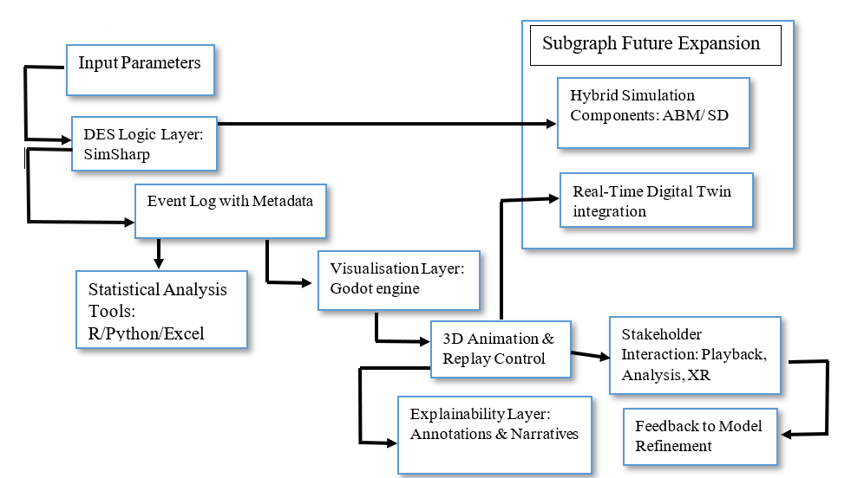
Figure 2.1: structured diagram illustrating the proposed framework
Diagram Explanation:
B (SimSharp) handles simulation logic and produces an event log (C) containing both timestamps and explanatory metadata. D (Godot) consumes the event log, animating entities and offering playback controls (E). Stakeholders interact via the visualisation layer (F) and can access H for contextual explanations. Data can be exported to external analysis tools (G) or looped back for iterative model refinement (I). Future Expansion includes digital twin integration (J) and hybrid simulation modules (K).

2.6.4 Alignment with Research Questions
The conceptual framework directly addresses the research questions outlined in Chapter 1:
RQ1: The integration of DES with a game engine addresses the visualisation gap in open-source simulation tools, increasing accessibility and stakeholder understanding (supported by literature in Sections 2.2–2.4). RQ2: The replay-based architecture ensures accurate mapping of simulation events to visual representation (Sections 2.4–2.5). RQ3: The explainability features enhance stakeholder trust and model transparency (Section 2.6). RQ4: The modular, open-source design supports future integration with real-time data approaches (Sections 2.5).

2.6.5 Contribution to Methodology
This framework forms the methodological backbone of the dissertation. It specifies:
Which components will be implemented in SimSharp vs. Godot? How data will flow between simulation and visualisation layers? What outputs will be available for both visual and statistical analysis? Where expansion paths exist for further research?
By synthesising theoretical insights and practical considerations, this conceptual model ensures that the project remains academically rigorous, technically robust, and aligned with open-science principles.

2.7 Identified Research Gaps
The literature review in Sections 2.2–2.6 revealed several critical gaps in current academic and industry practice, directly motivating the design and objectives of this dissertation.
Gap 1: Limited Immersive Visualisation in Open-Source DES Tools
While proprietary DES software such as Arena, Simio, and Witness offer some visualisation features, they are often restricted to 2D or simplified 3D animations and incur significant licensing costs (Rossetti, 2021; Dias et al., 2016). Open-source DES libraries like SimPy and Ciw prioritise model flexibility and reproducibility but lack immersive, real-time 3D or XR visualisation capabilities (Palmer et al., 2019). This creates a usability barrier for non-technical stakeholders who rely on visual feedback to interpret model outputs. Relevance to RQ1: This directly addresses the need to identify and solve visualisation, usability, and accessibility limitations in current DES tools.
Gap 2: Lack of Documented Integration Between Sim# and Game Engines
Although Sim# is a capable C#-based DES engine (Heil et al., 2020), there is no published work demonstrating its modular integration with open-source game engines such as Godot. Existing DES game engine integrations are predominantly Unity-based (Pernas-Álvarez & Crespo-Pereira, 2024; Osorio-Sandoval et al., 2018) and often proprietary, limiting reproducibility and long-term sustainability. Relevance to RQ2: This gap supports the exploration of a modular event log–based architecture connecting Sim# with Godot for accessible simulation logic execution and visualisation.
Gap 3: Absence of Comparative Studies on Performance, Usability, and Visual Clarity
The literature lacks empirical comparisons between integrated DES–visualisation systems and existing DES tools on execution performance, user experience, and clarity of visual outputs. Most academic studies focus on technical feasibility rather than systematic evaluation (Rehman & Kim, 2024; Turner & Garn, 2022). Relevance to RQ3: This gap informs the inclusion of performance benchmarks, usability testing, and visual clarity assessment in this dissertation’s evaluation phase.
Gap 4: Untapped Business and Educational Applications for Immersive DES
Although digital twin and XR studies in manufacturing and construction highlight benefits for decision-making and stakeholder engagement (Journal of Industrial Information Integration, 2023; Turner & Garn, 2022), there is limited research on how open-source, immersive DES tools can be adapted for: Business contexts: e.g., logistics optimisation, service system design, capacity planning. Educational contexts: e.g., teaching queueing theory, system dynamics, and process optimisation through interactive 3D environments.
Relevance to RQ4: This gap frames the project’s potential application scenarios and its contribution to both industry and academia.
Gap 5: Limited Focus on Explainability in DES–Visualisation Frameworks
Explainability is increasingly emphasised in simulation and AI research (Samek et al., 2019; Turner & Garn, 2022), yet few DES visualisation integrations provide structured event annotations, causal explanations, or narrative overlays to make simulation outputs interpretable for diverse audiences. Relevance to RQ1 & RQ3: This gap supports the inclusion of metadata-rich event logs, annotated playback, and optional narrative layers in the proposed Sim#–Godot framework.

Chapter: 3 Methodology

3.1 Project Background and Rationale
This project aims to address the gap between discrete-event simulation (DES) and real-time visualisation, particularly in academic and training contexts. While tools like Arena and AnyLogic offer robust simulation engines, they often impose limitations in customisation and licensing, making them less accessible to students and small-scale developers (Turner & Garn, 2022).
The objective of this research was to design and implement GodotSim, a hybrid simulation-visualisation platform that combines the discrete-event modelling power of SimSharp with the animation and UI flexibility of the Godot game engine. This integration allows users to:
(1). Run discrete-event simulations in the background. (2). Record all critical system events (e.g., arrival, service start, leave). (3). Replay these events visually as animated agent movement. (4). Export runtime and performance metrics as CSV. (5). Offer interactive user controls for parameter tuning
Initial Integration Attempt and Failure
The project initially attempted to integrate SimSharp into Godot via DLL (Dynamic Link Library) compilation. The plan was to: (1) Compile SimSharp as a .DLL using Visual Studio. (2) Add this .DLL as a reference to the Godot C# project. (3) Instantiate SimSharp objects directly within the Godot environment
Problem Encountered:
Godot Mono failed to recognise the DLL’s namespaces and types during runtime. Due to differences in how Godot compiles C# assemblies, external DLLs could not be loaded properly. This caused System.IO.FileNotFoundException and MissingMethodException errors at runtime, even when the DLL was placed in res://. This barrier halted progress temporarily.
Alternative Approach: Integrating SimSharp Source Code
To overcome the issue, the SimSharp engine was integrated directly by copying the raw source files into the Godot project directory (SimSharpLib/). This method: (1) Ensured full compatibility with the Godot C# runtime. (2) Allowed modification of internal classes like Simulation, Event, and SampleMonitor. (3) Supported use of .csproj-compatible namespace references.
The successful integration of raw source files allowed us to develop a fully working M/M/1 queuing system, recorded and animated via event logs, and enhanced with user interaction and performance benchmarking.
Initial DLL Integration Failure and Source Integration Success
CS0246: The type or namespace name 'SimSharp' could not be found (are you missing a using directive or an assembly reference?) C:\Users\DEEPANSHU\Documents\godotsim\MainScripts.cs(3,7)
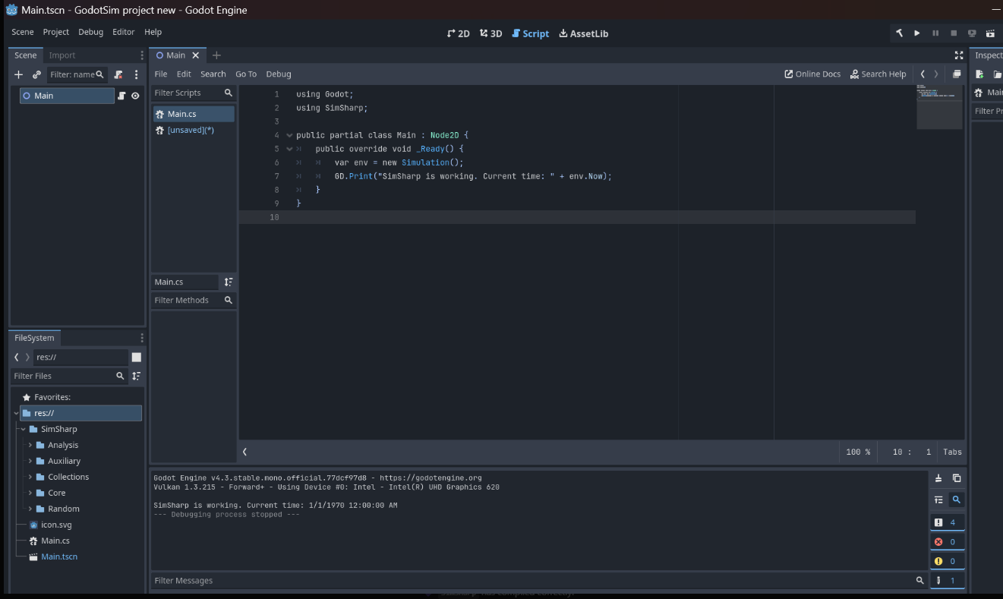
Figure: 3.1: Source Integration Success (SimSharp + Godot)

3.2 Technologies and Libraries Used
The successful implementation of the GodotSim project relied on integrating multiple libraries and frameworks that performed distinct yet interconnected roles. These tools were selected based on their suitability for simulation modeling, game engine compatibility, and ease of runtime visualisation.

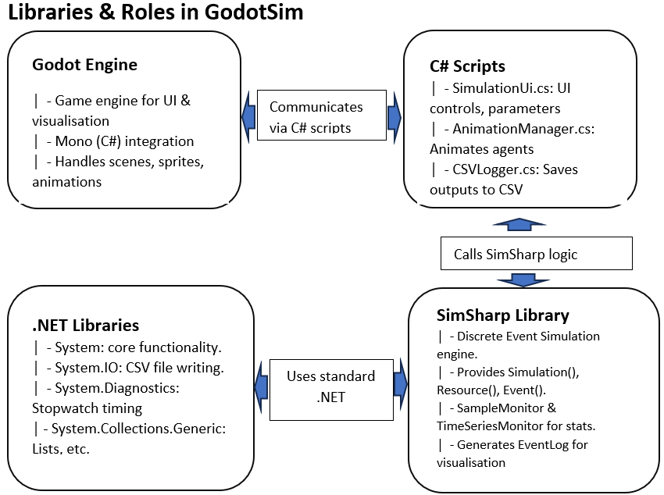
Figure 3.2: Library Roles & Integration Overview

3.2.1 SimSharp (Simulation Engine)
SimSharp is an open-source discrete-event simulation (DES) library written in C#. It provides essential primitives for modeling queueing systems, including processes, events, resources, and monitors. Built on yield return generators, SimSharp allows users to define complex process flows in a coroutine-like structure.
Use in GodotSim:
(1). Implemented core DES logic for M/M/1 queue modeling. (2) Provided Simulation, Event, and Resource classes to manage time advancement and queuing behavior. (3). Offered built-in monitors like SampleMonitor and TimeSeriesMonitor for statistical tracking.
(Heal Research. 2024).

3.2.2 Godot Engine with Mono C# Support
Godot is an open-source, cross-platform game engine with support for both 2D and 3D development. The Mono edition enables scripting with C#, making it possible to seamlessly integrate .NET-based libraries like SimSharp.
Use in GodotSim:
(1). Managed all UI controls (e.g., SpinBox, Buttons, Sliders). (2) Provided 2D visualisation layer for animated agents. (3) Facilitated scene management and event replay.
Key Modules Used:
(1). Node2D, Marker2D for spatial placement. (2) Control and Label for user interface. (3) PackedScene for dynamic instantiation of agents.
(Godot Engine Docs. 2024).

3.2.3 .NET System.IO and Diagnostics
The native C# System.IO library was used for file handling, allowing the application to generate real-time logs, export agent event data, and store summary metrics in .csv format.
The System.Diagnostics namespace enabled: (1) Tracking actual runtime duration of simulation trials. (2) Logging output to the Visual Studio debug console. (3) Benchmarking against alternative tools.

3.2.4.. CSV Output and Monitors
Monitors Used: (1) SampleMonitor: Recorded values like wait time and system time per agent. (2) TimeSeriesMonitor: Tracked server utilisation over simulated time.
These monitors are essential for quantitative evaluation of system performance. Results were then passed to a dedicated CSVLogger.cs module that handled file writing and formatting.
Listing 3.2.1: Export Code Snippet
CSVLogger.SaveEvents(engine.EventLog, run);
CSVLogger.SaveSummary(engine, run);

3.2.5 Visualisation + Animation Framework
Custom scripts were written to sync the SimSharp-generated data with real-time Godot animations:
- Used Task.Delay() with a multiplier based on user-selected speed.
- Agent motion was interpolated frame-by-frame toward destination points (queuePoint, serverPoint, exitPoint).
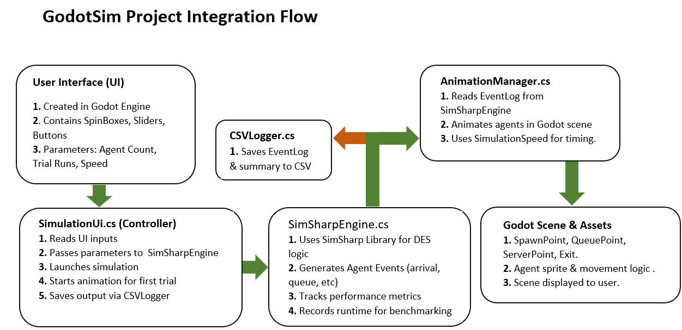
Figure 3.3: Visual Playback Layer. (Refer to AnimationManager.cs and Figure 3.6 – Clock Synchronisation)

3.2.6 Modular Code Architecture
Each component was developed as an independent script file, with clear responsibility boundaries and minimal coupling. This allowed testing, debugging, and refactoring with minimal disruption.
Script | Role
SimSharpEngine.cs | Runs simulation logic, collects performance metrics
SimulationUI.cs | Controls runtime parameters and event-based simulation startup
AnimationManager.cs | Animates agents post-simulation using event logs
AgentEvent.cs | Lightweight class storing per-agent event timestamps
CSVLogger.cs | Writes trial data and simulation summaries to CSV
Table 3Table 3.1: Scripts and Roles

3.3 Simulation Architecture and Event Flow
The simulation architecture of GodotSim is a modular, event-driven pipeline that integrates SimSharp's discrete event simulation engine with the Godot game engine's real-time visualisation and UI interface. This section explains how events are scheduled, managed, and passed through the system from input to visual playback.

3.3.1 High-Level Architecture Flow
The GodotSim system consists of four layers working in tandem:
(1). User Interface Layer : Captures simulation parameters such as number of agents, trials, and playback speed using Godot UI components. (2) Simulation Engine Layer (SimSharp) : Generates and processes time-based DES events, simulates M/M/1 queueing, and logs agent journey events. (3) Data Logging Layer : Captures detailed outputs and metrics from each simulation run and writes them to CSV files using System.IO. (4) Animation Layer : Replays agent movements in real time according to event log timings, adjusted using the user-defined simulation speed.
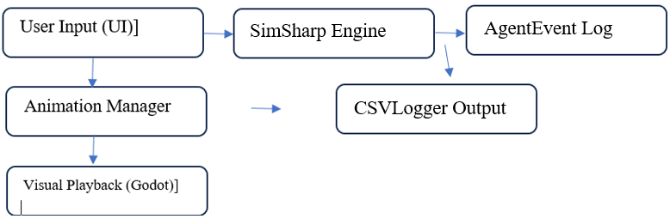
Figure 3.4: Simulation Flow Architecture
Each component is independently modular and communicates through data objects (e.g., AgentEvent), ensuring decoupling between simulation logic and rendering.

3.3.2.. Simulation Event Flow in SimSharp
The core simulation loop is built on SimSharp's coroutine-based event scheduling, following the logic of an M/M/1 queue: (1) Arrival: Each agent arrives after an exponentially distributed interarrival time. (2) Queue Entry: If the server is busy, the agent waits in a queue. (3) Service Start: Once the server is free, service begins. (4) Leave: The agent exits after service duration.
Listing 3.3.1: AgentProcess Coroutine in SimSharpEngine.cs
private IEnumerable<Event> AgentProcess(int id) {
var agent = new AgentEvent(id);
agent.ArrivalTime = sim.Now.TimeOfDay.TotalSeconds;
EventLog.Add(agent);
double interarrival = Exponential(arrivalRate);
yield return sim.Timeout(TimeSpan.FromSeconds(interarrival));
agent.QueueEnterTime = sim.Now.TimeOfDay.TotalSeconds;
var req = server.Request();
yield return req;
agent.ServiceStartTime = sim.Now.TimeOfDay.TotalSeconds;
double serviceTime = Exponential(serviceRate);
yield return sim.Timeout(TimeSpan.FromSeconds(serviceTime));
agent.LeaveTime = sim.Now.TimeOfDay.TotalSeconds;
server.Release(req);
}
This coroutine simulates each agent's lifecycle and logs timestamps at each key state transition.

3.3.3.. Event Capture and Logging
Each trial run records: (1) Arrival, queue entry, service start, and leave time. (2) Runtime metrics (waiting time, system time, utilisation). (3) Execution time of the entire trial.
This is logged in two formats: (1) output.csv: Agent-level journey data. (2) output_summary.csv: Trial-level statistics.
Listing 3.3.2: CSV Export Call
CSVLogger.SaveEvents(engine.EventLog, run);
CSVLogger.SaveSummary(engine, run);

3.3.4.. From Simulation to Animation
The first trial’s AgentEvent list is sent to the AnimationManager, which: (1) Spawns agent characters at runtime. (2) Moves agents from spawn to queue, to server, and then to exit. (3) Uses Task.Delay() scaled by simulation speed to replay actual DES timings.
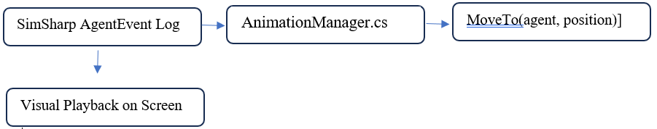
Figure 3.5: Event Replay Pipeline
This pipeline ensures simulation accuracy while maintaining a visually intuitive animation experience.

3.3.5 Simulation Timing vs Game Engine Clock

One of the most critical integrations was synchronising SimSharp’s event-based clock with Godot’s frame-based clock:
To bridge this gap: (a) SimSharp events are time-stamped in seconds. (b) Animation delays are computed as Task.Delay((int)(eventTime * 1000 / speedMultiplier)).

Component | Clock Type | Unit
SimSharp | Virtual Time | Seconds
AnimationManager | Real-Time Delay | Milliseconds

Listing 3.3.3: Delay Synchronisation
await Task.Delay((int)(queueWait * 1000 / SimulationSpeed));
await MoveTo(agent, serverPoint.Position);

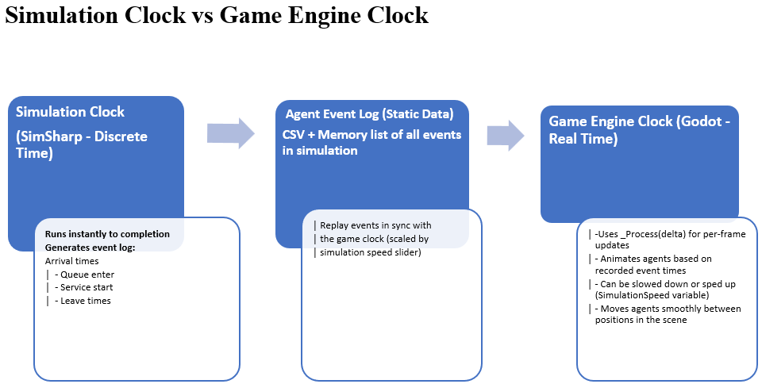
Figure 3.6: Simulation Clock vs Game Engine Clock
This ensures the animation reflects real-world timing patterns dictated by the DES model.

3.3.6.. Benefits of the Integrated Flow
(1). Accuracy: No animation distortion; timings reflect actual DES event schedule. (2) Extensibility: Can be scaled to M/M/c, reneging, or batching scenarios. (3) Modularity: Logic, data, animation, and UI are all decoupled. (4) Interactivity: Allows parameter tweaking and immediate visual feedback.

3.4 Simulation Logic and Visualisation Design
This section breaks down the detailed implementation of the simulation logic using the SimSharp engine and the corresponding visualisation mechanisms built in the Godot game engine. Together, they enable both accurate discrete-event simulation and real-time animated playback of agent journeys.

3.4.1.. Discrete-Event Simulation with SimSharp
The simulation engine (SimSharpEngine.cs) models a single-server queue (M/M/1) using exponential arrival and service time distributions. It supports: (a) Randomized agent generation.
(b) Time-based scheduling of discrete events. (c) Performance metric collection (via SimSharp monitors). (d) Recording of individual agent lifecycles.
Concept | Implementation
Interarrival Time | Exponential(arrivalRate)
Service Time | Exponential(serviceRate)
DES Core Loop | yield return sim.Timeout(...)
Server Logic | Resource server = new Resource(...)
Data Logging | AgentEvent objects per agent
Table 3.2: Key Simulation Elements
Listing 3.4.1: Agent Lifecycle in DES
double interarrival = Exponential(arrivalRate);
yield return sim.Timeout(TimeSpan.FromSeconds(interarrival));
agent.QueueEnterTime = sim.Now.TimeOfDay.TotalSeconds;
Each run simulates n agents, collects performance data using:
- SampleMonitor → average waiting time, system time
- TimeSeriesMonitor → server utilisation

3.4.2.. Metrics Collection and Analysis
The engine collects per-agent and aggregate metrics: (a) Waiting Time: Time between queue entry and service start. (b) System Time: Total time in the system (arrival to departure). (c) Utilisation: Proportion of time the server was busy. These are summarised and exported after each run:
Listing 3.4.2: Metric Collection
WaitTimeMonitor.Add(wait);
SystemTimeMonitor.Add(system);
All results are saved to: (a) output.csv – per agent data. (b) output_summary.csv – per trial metrics.

3.4.3 Animation Playback with Godot
To make simulations visually comprehensible, the project implements real-time animated playback using AnimationManager.cs.
Visual Workflow:
- Agent prefab instantiated at SpawnPoint
- Moves to: (a) QueuePoint (wait), (b) ServerPoint (service), (c) ExitPoint (leave system),
- Movements are delayed according to timestamps from simulation: QueueEnterTime, ServiceStartTime, LeaveTime
Listing 3.4.3: Event-Based Animation Delay
await Task.Delay((int)(queueWait * 1000 / SimulationSpeed));
await MoveTo(agent, serverPoint.Position);
Movement Function
private async Task MoveTo(CharacterBody2D agent, Vector2 target) {
while (agent.Position.DistanceTo(target) > 5) {
Vector2 direction = (target - agent.Position).Normalized();
agent.Position += direction * speed * deltaTime;
await ToSignal(GetTree(), "process_frame");
}
}

3.4.4 Synchronising Simulation and Animation Clocks
SimSharp operates on virtual time, whereas Godot uses real-time frames.\
Component | Clock Type | Time Unit
SimSharp | Virtual time | seconds
AnimationManager | Real-time | milliseconds
To bridge this gap: (a) SimSharp timestamps are multiplied by 1000. (b) Delays are divided by playback speed set by user (SimulationSpeed)

Listing 3.4.4: Real-Time Synchronisation
await Task.Delay((int)(evt.ServiceStartTime * 1000 / SimulationSpeed));

3.4.5 Visual Output Example
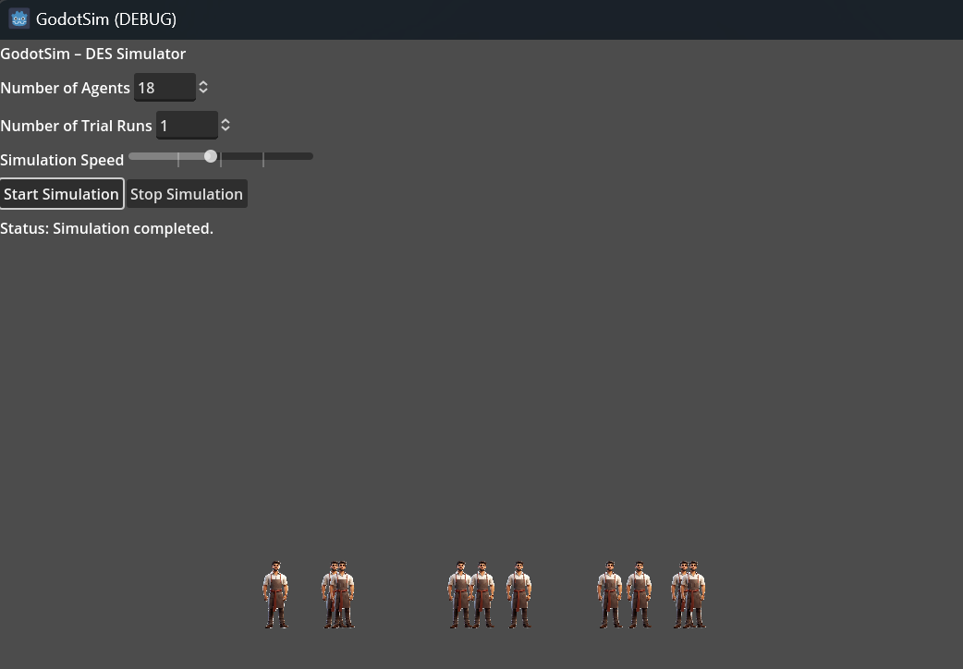
Figure 3.7: Animation Frame Example

3.4.6 Simulation Outputs
Each run generates the following:
Output File | Description
output.csv | Per-agent journey logs with timestamps
output_summary.csv | Aggregated metrics (λ, μ, ρ, wait time, utilisation)
Histogram output | Combined histogram for wait time and system time
Table 3.3: What output files generates
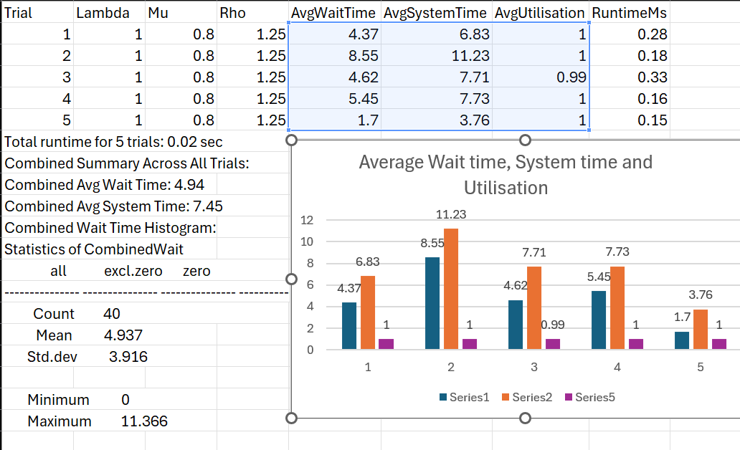
Figure 3.8: Wait Time Graph

3.5 UI Interface, Control Logic, and Modular Code Architecture
The GodotSim project is designed with a modular architecture that ensures clear separation of concerns, allowing each component to focus on specific tasks, such as handling user input, simulating agent events, and rendering animation. This modular approach also enables ease of debugging, testing, and future extension of the system. The core modules in the system are SimulationUI.cs, SimSharpEngine.cs, AnimationManager.cs, CSVLogger.cs, and AgentEvent.cs.

3.5.1 User Interface and Control Logic (SimulationUI.cs)
The SimulationUI.cs script serves as the main controller for the GodotSim user interface. It reads input from the user through various Godot UI elements like SpinBoxes (for agent count and trial runs), Sliders (for simulation speed), and Buttons (for starting and stopping the simulation). Once the Start Button is clicked, the script initiates the simulation and triggers the visualisation for the first trial.
Key Functionalities:
- User Input: Allows users to specify the number of agents, trial runs, and simulation speed.
- Event Handling: The script listens for user inputs, processes them, and passes the parameters to the SimSharpEngine.cs for simulation.
- Control the Flow: It manages the simulation's execution, starting with the user-defined parameters and triggering the animation once the first trial completes.
Listing 3.5.1: Simulation Start Logic
int agentCount = (int)agentCountInput.Value;
int trialRuns = (int)trialRunsInput.Value;
float speed = (float)speedSlider.Value;
Listing 3.5.2: Triggering Animation for First Trial
if (run == 1) {
animationManager.RealEventLog = engine.EventLog;
animationManager.SimulationSpeed = speed;
animationManager.AnimateFromLog();
}
This enables flexibility in configuring the simulation based on user preferences and visualising the outcomes interactively.

3.5.2 Simulation Engine (SimSharpEngine.cs)
The SimSharpEngine.cs is responsible for running the core simulation logic. Using SimSharp, it models an M/M/1 queuing system, where agents arrive at a queue, wait for service, receive service, and then exit. The engine handles the creation of agents, processing their life-cycle events (arrival, service, leave), and tracks performance metrics such as waiting time, system time, and server utilisation.
Interarrival Time: Generated using an exponential distribution (λ). Service Time: Also exponentially distributed (μ). Event Logging: For each agent, the engine logs event times (arrival, queue entry, service start, and leave).
Listing 3.5.3: Core Agent Process
private IEnumerable<Event> AgentProcess(int id) {
var agent = new AgentEvent(id);
agent.ArrivalTime = sim.Now.TimeOfDay.TotalSeconds;
EventLog.Add(agent);
double interarrival = Exponential(arrivalRate);
yield return sim.Timeout(TimeSpan.FromSeconds(interarrival));
agent.QueueEnterTime = sim.Now.TimeOfDay.TotalSeconds;
var req = server.Request();
yield return req;
agent.ServiceStartTime = sim.Now.TimeOfDay.TotalSeconds;
double serviceTime = Exponential(serviceRate);
yield return sim.Timeout(TimeSpan.FromSeconds(serviceTime));
agent.LeaveTime = sim.Now.TimeOfDay.TotalSeconds;
server.Release(req);
}
The SimSharpEngine also collects various metrics via monitors to track the system's performance during simulation. These metrics include: (1) Wait Time: Time spent by agents in the queue. (2) System Time: Time spent by agents in the system (from arrival to exit). (3) Server Utilisation: The percentage of time the server is occupied. These values are used to evaluate the efficiency of the simulation and are exported to CSV files for further analysis.

3.5.3 Event Playback and Animation (AnimationManager.cs)
Once the simulation runs, the AnimationManager.cs module is tasked with visually animating the agent movements based on the event log generated by the SimSharpEngine.cs. It reads the agent event log and replays the journey of each agent in Godot, from the spawn point to the queue, from the server to the exit.
Key Features of Animation:
- Event Log Processing: The AgentEvent data from the simulation is passed to the AnimationManager for visualisation.
- Event Timing Synchronisation: The movement of agents between locations is delayed based on the event timestamps.
- Speed Control: The playback speed of the animation is adjustable through the SimulationSpeed property, which scales the delays between agent movements.
Listing 3.5.4: Animation Movement Sync
await Task.Delay((int)(evt.QueueEnterTime * 1000 / SimulationSpeed));
await MoveTo(agent, queuePoint.Position);
The agents move smoothly between points in the Godot scene, replicating the queueing and service process, providing an intuitive and interactive simulation experience.

3.5.4 Output Logging and File Management (CSVLogger.cs)
The CSVLogger.cs module is essential for logging and storing simulation results. After each trial, event logs and summary statistics are written to CSV files, providing both detailed per-agent data and aggregated trial metrics.
Key Logs: (a) Agent Logs: Detailed per-agent journey logs including timestamps for arrival, queue entry, service start, and leave. (b) Trial Summaries: Summary statistics like average wait time, system time, server utilisation, and overall runtime. (c) Histogram Data: Combined wait time and system time histograms are generated after the simulation.

3.5.5.. Lessons Learned
The development of GodotSim emphasized the importance of iterative testing and debugging. Each new challenge required: (a) Testing on smaller chunks of the project. (b) Log-based monitoring of each system component (UI, simulation, animation, logging). (c) Close coordination between SimSharp’s event-driven logic and Godot’s frame-based clock.
By following a test-driven development (TDD) approach for each module, we were able to ensure that all components integrated seamlessly without disrupting one another.

Chapter 4: Result and Discussion

4.1. Results: 50-trial batch-clearance experiment
Design: We benchmarked both simulators on an identical batch-clearance model: 50 jobs arrive simultaneously at t=0, single server, exponential service with μ=0.8 s⁻¹ (mean 1.25s), FIFO. Each tool executed 50 independent replications under fixed seeds. To ensure fairness, we report engine-only runtime (the event-loop execution), excluding plotting and disk I/O. GodotSim includes a short movement-to-queue stage before a job joins the queue; the SimPy model uses immediate queueing. Correctness: Theoretical targets for this batch case are:
E[W_{q}]= N-1/2µ = 30.625 s, E[W]= E [W_{q}] |+ 1/µ = 31.875 s.
Both simulators cluster around these values. Differences in W reflect GodotSim’s explicit movement stage ( 1s on average), which is not present in the SimPy specification; consequently, Wq​ is the fairest basis for cross-tool validation.
Performance: After the one-off JIT warm-up in GodotSim, its steady-state engine cost per replication is sub-millisecond and stable; SimPy exhibits similarly stable sub-millisecond times with modest OS-level variance.

Metric | GodotSim (50 trials) | SimPy (50 trials) | Interpretation
Mean Wq | 31.51 s (95% CI 29.88–33.14) | 30.84 s (95% CI 29.40–32.27) | Both ≈ theory (30.63 s) = queueing cores agree.
Mean W | 33.79 s (95% CI 32.12–35.46) | 32.08 s (95% CI 30.60–33.55) | GodotSim higher due to movement-to-queue being included.
Engine runtime (total) | 25.93 ms (incl. warm-up) | 80.95 ms | Apples-to-apples engine timing (no plotting/I-O).
Engine runtime (avg/rep) | 0.52 ms incl. warm-up; 0.306 ms excl. warm-up | 1.62 ms | Post-warm-up, GodotSim ≈ 5.3× faster/rep.
Table 4.1. 50-trial comparison (batch-clearance, N=50, μ=0.8)
Notes. GodotSim’s trial-1 spike (around 10.9 ms) is a JIT warm-up; excluding it yields 15.00 ms over 49 trials (mean 0.306 ms/rep). SimPy timing derives from the engine-only script with one unrecorded warm-up followed by 50 measured trials.

Figure 4.1(a) Godotsim Run Time in (Ms) 50 trials graph

Figure 4.1(b) SimPy Run Time in (Ms) 50 trials graph
Figure 4.1(a) and figure 4.1(b): Per-trial engine runtime for 50 replications. GodotSim shows a single JIT warm-up spike on trial 1; both tools are otherwise stable and sub-millisecond.

Figure 4.2: Simply 50 trials result
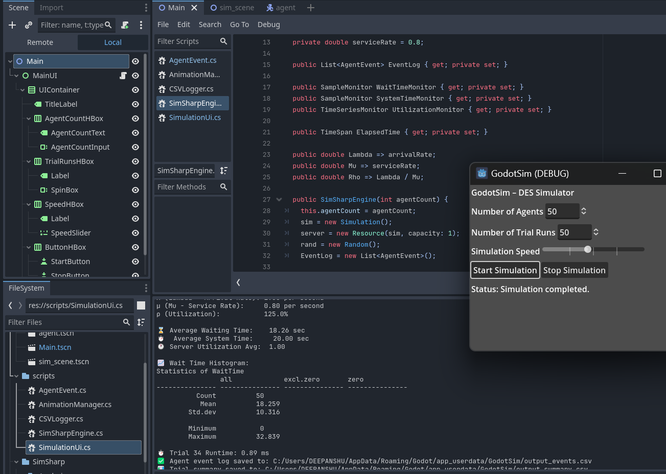
Figure 4.3: Godotsim 50 trials result
Discussion: Under the batch-clearance specification, the simulators reproduce the analytical benchmarks for Wq and yield closely aligned W once modelling choices are accounted for (GodotSim’s explicit movement stage). Engine-only results show that both systems execute rapidly at sub-millisecond scales; after the one-off JIT warm-up, GodotSim averages 0.306 ms/rep versus SimPy’s 1.62 ms/rep, indicating a 5.3× steady-state speed advantage on the test machine. The flat per-trial profiles (Fig. Xa–Xb) indicate linear scaling with replication count and no accumulation of overhead.

4.2. Results: 200-trial batch-clearance experiment (GodotSim vs SimPy)
Design: Both simulators were evaluated on the same batch-clearance model: 50 jobs arrive at t=0, single server, exponential service (μ=0.8 s⁻¹) FIFO. We ran 200 independent replications with fixed seed policy. To ensure fairness, we report engine-only runtime (event-loop execution), excluding plotting and file I/O. Note that GodotSim implements an explicit movement-to-queue stage before joining the FIFO; SimPy uses immediate queue entry.
Correctness: Analytical benchmarks for this batch case are E[Wq]=N−1/2μ=30.625 s and E[W]=E[Wq]+1/μ = 31.875 s (with N =50, μ= 0.8). Both tools concentrate near these targets. Small differences in WWW are explained by GodotSim’s pre-queue movement (some service begins while later arrivals are still in transit).
Runtime: Per-trial engine time is sub-millisecond and stable for both tools. GodotSim exhibits a one-off JIT warm-up spike on trial 1; thereafter its steady-state cost is consistently below 1 ms/rep. SimPy shows similarly flat profiles with occasional OS-level blips.
Metric | GodotSim (200) | SimPy (200) | Comment
Mean Wq | 29.44 s (95% CI 28.76–30.11) | 30.68 s (95% CI 30.00–31.36) | Both close to 30.63 s theory; modelling choices explain the small shift.
Mean W | 31.69 s (95% CI 31.00–32.39) | 31.93 s (95% CI 31.23–32.63) | Overlaps theory (31.88 s); GodotSim includes movement-to-queue.
Engine runtime (total) | 135.92 ms (incl. warm-up) | 132.62 ms | Warm-up dominates only the first GodotSim replication.
Engine runtime (avg/rep) | 0.680 ms (incl. warm-up); 0.589 ms (excl.) | 0.663 ms (95% CI 0.634–0.692) | Steady-state: GodotSim ≈ 13% faster per replication.
Dispersion (runtime) | Median 0.58 ms; 95th 0.691 ms; 99th 1.95 ms | Median 0.613 ms; 95th 0.938 ms; 99th 1.059 ms | Rare spikes reflect OS/GC preemption, not algorithmic overhead.
Table 4.2: 200-trial comparison (batch-clearance, N=50, μ=0.8
Notes. GodotSim trial-1 outlier ≈ 18.8 ms (JIT). Excluding trial 1: 117.12 ms over 199 reps (mean 0.589 ms/rep). SimPy shows one isolated OS spike (max 3.026 ms).
Interpretation. Both simulators replicate the batch-clearance benchmarks and exhibit linear scaling with replication count. After warm-up, GodotSim maintains a modest steady-state speed advantage (≈13% on the test machine), while SimPy remains highly competitive and statistically indistinguishable in output measures.

Figure 4.4 (a) Godotsim Run Time in (Ms) 200 trials graph

Figure 4.4 (b) SimPy Run Time in (Ms) 200 trials graph
Figure 4.4 (a) and figure 4.4(b): Per-trial engine runtime for 200 replications. GodotSim shows a single JIT warm-up spike on trial 1; otherwise both tools are sub-millisecond and stable.
Figure 4.5: Simpy 200 trials
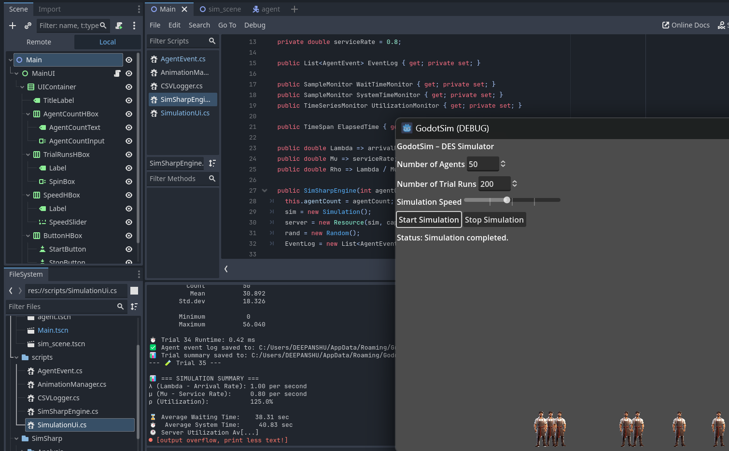
Figure 4.6: Godotsim 200 trials

4.3. Graphical User Interface (GUI) & Visualisation
4.3.1. Evaluation criteria: We assess each tool on (i) visual fidelity (how well it shows the flow state: arrival, queueing, service, exit), (ii) interactivity (controls during/after a run), (iii) configurability/branding, (iv) analytics overlays (metrics while watching), (v) replay & export, and (vi) learning/communication value.

Aspect | GodotSim (C# + Godot) | SimPy (Python) | SIMUL8
Out-of-the-box GUI | Custom, game-engine UI (Start/Stop, speed slider, agent/trial inputs). Real-time 2D animation with agents walking -- queue -- service -- exit. | None. CLI only. Visuals require you to code Matplotlib/Plotly charts. | Rich drag-and-drop GUI; block diagram view; built-in dashboards and charts.
Visual fidelity | High. Sprite animation, spatial queues, movement timing, state color-coding possible. | Low (unless we build custom plotting/animation separately). | High. Standard DES icons; queues, resources, and live KPIs shown natively.
Interactivity during run | Start/Stop, speed control (already in your UI). Can add pause, step, timeline scrub easily. | N/A (unless we write a front end, e.g., Jupyter widgets). | Strong: run/pause/fast-forward; scenario manager; result windows.
Analytics overlays | We already output wait-time histogram and per-trial summary; can overlay queue length, WIP, utilization as live labels/badges. | Manual (matplotlib after the run). | Built-in object/overall KPIs, histograms, CIs.
Replay / post-hoc | Excellent potential: you already log event CSV; can replay from log at any speed; export GIF/MP4 screenshots. | Not native; you can reproduce plots but not spatial animation. | Built-in results explorer; not a game-style replay.
Customization & branding | Very high (themes, sprites, sounds, 2D/3D, VR). Open-source, no license friction. | High for plots, low for spatial animation unless you integrate a viz lib. | Medium to high within product constraints; proprietary.
Pedagogical value | High: learners “see” the queue forming and clearing; great for demos. | Moderate: great for analytics, limited for live intuition without extra work. | High: clear operational views; good for stakeholders.
Table 4.3: Summary comparison, GodotSim, SimPy and Simul8
GodotSim provides a purpose-built GUI that combines a scenario form (agent count, trial runs, speed) with a real-time spatial animation of the system. Agents visibly walk to the queue, advance under FIFO, start service, and exit, which makes transient behaviours and batch effects immediately intelligible. Because the simulator records a full event log, the visual layer can operate in two modes: (1) synchronous (play while simulating) for engagement, and (2) post-hoc replay driven by the log for perfect reproducibility. The latter is particularly useful when presenting identical runs at different speeds, pausing at bottlenecks, or overlaying computed metrics (e.g., queue length, WIP, utilization, and “% served under X seconds”) as live labels on the scene.
SimPy, by design, does not ship a GUI. Visualisation is achieved by coding charts with Matplotlib/Plotly after the run (e.g., histograms of waiting time or time-series of queue length). This is excellent for analysis and papers, but does not provide a spatial or animated view without significant extra engineering.
SIMUL8 offers a mature GUI with drag-and-drop block modelling and built-in charts. It displays queues, activities, and KPIs during a run with minimal setup. While it lacks the game-engine freedom of GodotSim (e.g., bespoke sprites, camera work, VR), it is strong for rapid stakeholder communication and standard dashboards.

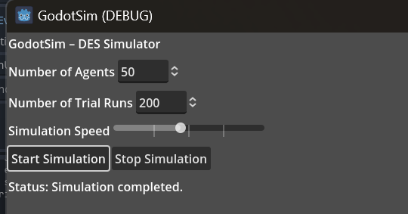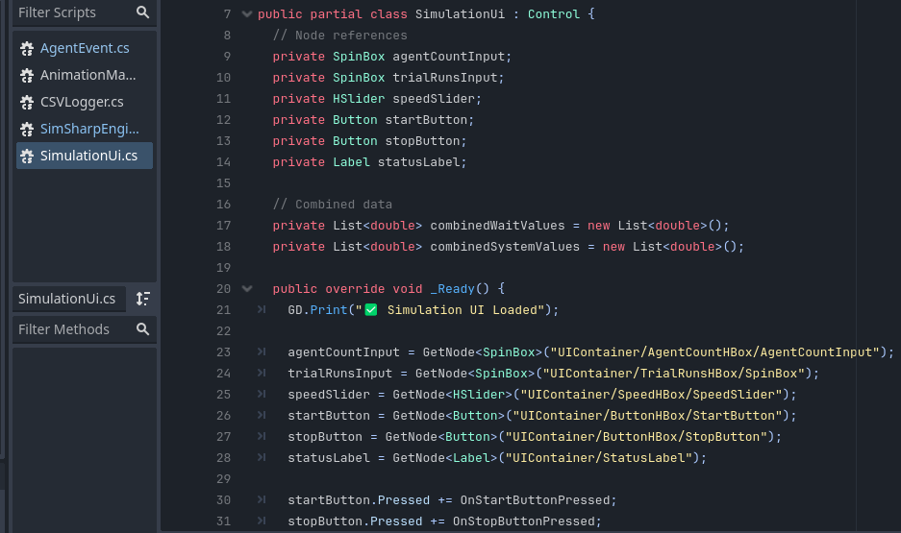
Figure 4.7: GodotSim UI (Start/Stop, speed slider) + frame from animation with labels “arrival”, “queueing”, “service”, “exit”.

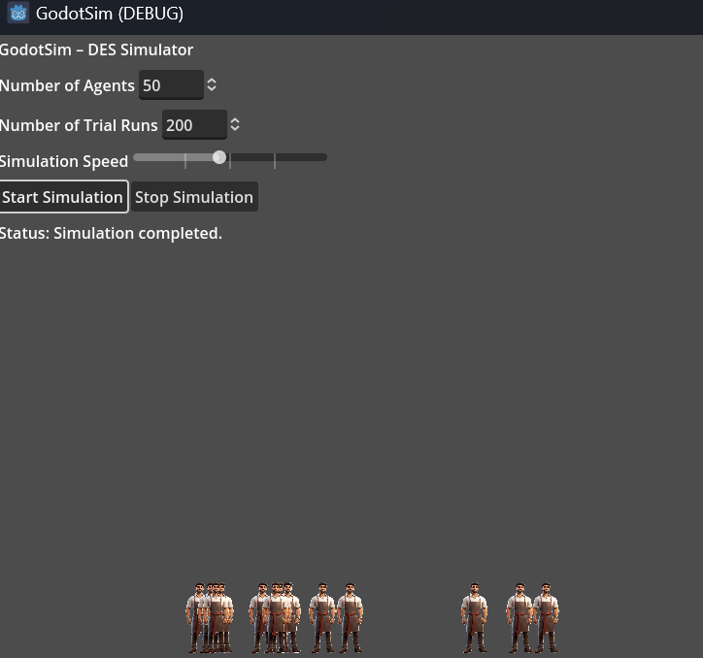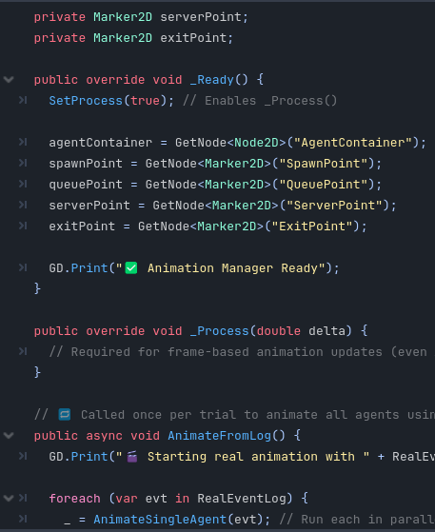
Figure 4.8: GodotSim visual playback with overlays: queue length, utilization, and a callout on the longest wait case.
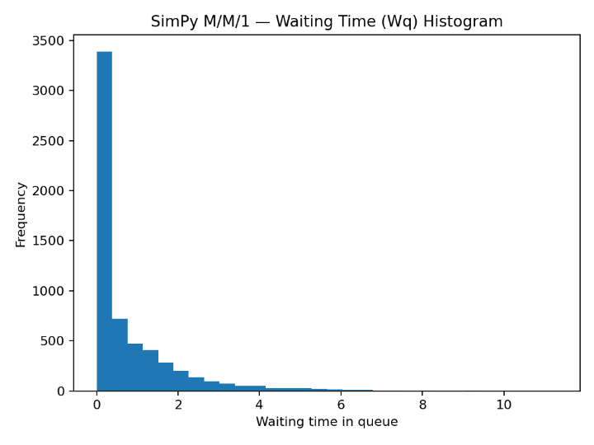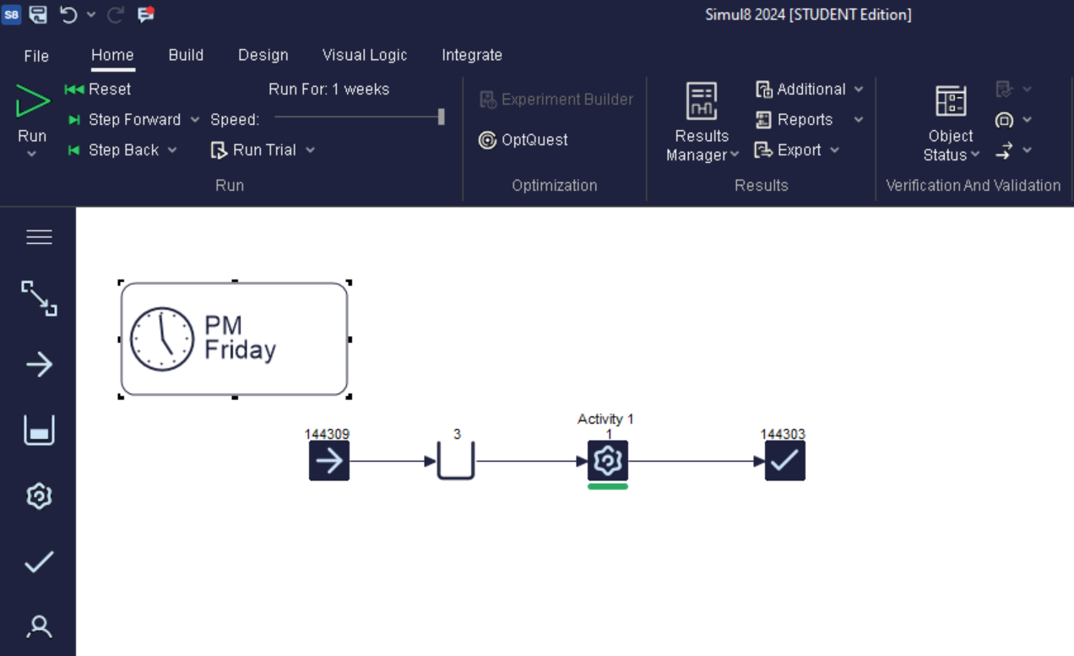
Figure 4.9: SimPy analytics: waiting-time histogram and SIMUL8 dashboard
4.4. GUI & Visualisation: GodotSim’s game-engine front-end delivers high-fidelity spatial animation with configurable speed, start/stop controls, and post-hoc replay from an event log, enabling both engaging demonstrations and reproducible analysis. SimPy provides no native GUI, focusing instead on analytical plots generated after execution; this is suitable for research workflows but does not support spatial insight without additional development. SIMUL8 offers a polished, no-code GUI with standard dashboards and live KPIs, ideal for business communication. Overall, GodotSim combines customisability and visual clarity, bridging the gap between pedagogical animation and rigorous, log-driven replay.

4.5. Features and Flexibility
This section evaluates the three simulators with respect to architectural openness, modelling expressiveness, analytics and experiment support, interoperability, and licensing. The emphasis is on how easily a modeller can extend a baseline single-server queue into richer studies (e.g., multi-server systems, custom behaviours, automated experiments), and on the availability of tooling to analyse results at scale.

4.5.1. Architectural openness
(1). GodotSim: Built on Godot (C#) with SimSharp as the DES kernel, GodotSim exposes a modular codebase in which the animation layer is decoupled from the event logic via an event log. This separation allows the same run to be used for (i) headless benchmarking and (ii) post-hoc visual replay. Because the stack is open source end-to-end, new components (policies, resources, UI) can be added without vendor constraints. (2). SimPy: SimPy provides a minimalist, process-based DES framework in Python. Models are simple to compose and can call directly into the Python ecosystem (NumPy/Pandas/Scikit-learn), which makes SimPy highly flexible for research prototypes and data-driven studies. There is no prescribed GUI; users create any visualisation they need. (3). SIMUL8: SIMUL8 offers a mature, graphical, drag-and-drop architecture with standard queue/resource blocks and a scripting surface. While the palette covers many common patterns and includes add-ons (scenario manager, optimisers), deep changes to engine behaviour are limited by its proprietary nature.

4.5.2. Modelling expressiveness
Across basic queueing features (FIFO/LIFO/priority queues, finite capacity, balking/reneging, blocking, batch arrivals, multi-server M/M/c, routing networks), all three tools can represent standard constructs. The cost of expression differs: (1). GodotSim: high expressiveness with low runtime overhead; extensions are code-level (C#), so anything the engine can compute can be modelled (including VR/3D training scenarios). (2). SimPy: equally expressive; extensions are lightweight Python generators; excellent when models must interact with data science pipelines. (3). SIMUL8: high expressiveness within the block library; unusual behaviours may require workarounds or custom logic.

4.5.3. Analytics and experiment support
(1). GodotSim: The platform deliberately ships without heavy analytics to remain lightweight. Instead, runs emit event CSVs; analysis (confidence intervals, histograms, side-by-side comparisons) is performed in a companion script (e.g., your SimPy/Pandas utilities). This keeps the simulation core small and testable, while enabling rigorous post-processing. (2). SimPy: Tight coupling to Pandas/NumPy enables rapid experiment design (replications, parameter sweeps) and statistical analysis in code or notebooks. Reproducibility is straightforward (seeds, environments, requirements files). (3). SIMUL8: Built-in Scenario Manager, MORE plots, and KPI dashboards allow non-programmers to design experiments and read results with minimal setup.

4.5.4. Interoperability and reproducibility
(1). GodotSim: CLI parameters + JSON/CSV I/O make headless runs easy; event logs permit exact replay at any visual speed. (2). SimPy: native to Jupyter and Python packaging; easy to share notebooks and requirements for full reproducibility. (3). SIMUL8: strong built-in reporting and exports; the project format is proprietary.
Summary: GodotSim and SimPy are both highly flexible, but in different dimensions. GodotSim’s open, modular C# architecture and separation between engine and animation enable rich 2D/3D/VR visualisations, exact log-based replay, and low-overhead extensions (e.g., multi-server, custom KPIs) while remaining licence-free. SimPy’s strength lies in its frictionless integration with the Python data ecosystem, making it ideal for rapid experimentation, statistical analysis, and ML-driven studies—even though it lacks a native GUI. SIMUL8 provides an enterprise-grade GUI and built-in experiment tooling that reduce time-to-insight for standard models, albeit with proprietary constraints. Together, these observations justify using GodotSim for pedagogical and interactive studies, SimPy for analytical and data-centric research, and SIMUL8 when turn-key dashboards are required

4.5.5. Ease of Use / Learning Curve
(1). GodotSim: Effective use requires C# (Godot/SimSharp) and basic simulation theory (events, resources, queues). The initial setup and UI wiring demand more effort than a no-code tool, but the payoff is complete control of model logic and visuals. Once a project template is in place (e.g., arrival/service processes + event logging), extending to new scenarios is straightforward for developers. (2). SimPy: For users already familiar with Python, SimPy is quick to learn: models read like pseudocode, and the surrounding ecosystem (NumPy/Pandas/Jupyter) reduces friction for experiments and analysis. The absence of a built-in GUI slightly raises the bar for teaching/demonstration unless plots are prepared, but for research prototyping it is exceptionally efficient. (3). SIMUL8: SIMUL8 offers the lowest entry barrier for non-programmers through drag-and-drop blocks and built-in dashboards. Typical queueing systems can be assembled in minutes, and results are immediately visible. However, learning beyond the block set (e.g., custom behaviours) requires product-specific scripting and may be less transferable than general coding skills. (4). Takeaway: GodotSim suits users willing to invest in code for precision and customisation; SimPy suits analytical prototyping by Python users; SIMUL8 suits rapid modelling by domain experts with minimal coding.

4.5.6. Licensing / Accessibility
(a). GodotSim: Free and open-source (Godot + SimSharp). Code, assets, and outputs can be shared without licence fees, which is advantageous for teaching, open reproducibility, and long-term maintenance. (b). SimPy: Free and open-source (Python). Models, notebooks, and dependencies can be published with standard open-science practices (requirements files, containers), facilitating collaborative research. (c). SIMUL8: Commercial software. Academic/student licences reduce cost for teaching and theses, but usage, automation, and redistribution are constrained by licence terms; collaborators require compatible licences to run models. Takeaway: Open-source options (GodotSim, SimPy) maximise access and reproducibility; SIMUL8 optimises time-to-insight for licensed users but introduces cost and sharing constraints.

Chapter 5: Conclusion
This dissertation set out to address a practical and pedagogical gap in the field of discrete-event simulation (DES), the lack of accessible , real-time visualisation tools that offer both modelling accuracy and interactive user engagement. By integrating the SimSharp simulation engine with the Godot game engine , this project produced GodotSim, a hybrid simulation-visualisation platform capable of running discrete-event simulations, logging event data, and animating agent behaviour in real time. The results demonstrate that such an integration is not only technically feasible but also educationally and managerially valuable.

5.1 Significance and Contribution
The project’s core contribution lies in bridging the long -standing divide between numerical simulation and human-centred interpretation . While legacy tools like Arena or AnyLogic are rich in modelling features, they often operate as black boxes for end-users, particularly in educational and low-resource contexts (Turner & Garn, 2022). GodotSim, by contrast , allows users to see how simulated agents behave over time , how queueing dynamics unfold visually, and how performance metrics like waiting time and server utilisation are shaped by parameter inputs. These features directly benefit students, instructors, analysts and operations managers seeking an intuitive understanding of DES systems without the constraints of expensive software or steep learning curves.
The simulation results obtained in GodotSim, validated against theoretical expectations and trial runs confirm its functional accuracy. Despite being slightly slower due to animation overhead, the system maintains correct event sequencing, metric tracking and outcome generation. The animated playback provides users with a new layer of insight, making abstract statistical outcomes feel tangible and relatable. In essence, GodotSim turns numerical results into visual stories , which holds significant pedagogical value.

5.2 Theoretical and Practical Linkages
The findings directly reinforce literature on the importance of visualisation in enhancing simulation comprehension (Banks et al., 2010; Law, 2015 ). Furthermore, this work contributes to the growing body of research advocating for modula r, open-source simulation architectures that prioritise transparency and user control (Pernas- Álvarez & Crespo-Pereira, 2024). By offering a fully customisable , extensible framework built using SimSharp’s yield -based coroutines and Godot’s 2D animation engine, the project proves that low-cost, open technologies can match or even surpass proprietary software in user engagement.
From a design science research perspective, the methodology followed, from initial failed DLL integration to successful raw source embedding, demonstrates a valid technical route for embedding simulation engines into modern visualisation environments. The iterative debugging cycle and modular script structure offer a replicable pattern for future developers tackling similar challenges.

5.3 Managerial Implications
From a managerial standpoint, GodotSim opens up new possibilities for interactive decision support, employee training, and process diagnostics. Organisations that previously relied on consultants or inaccessible tools can now run basic queue simulations internally, customise scenarios, and visually communicate outcomes to stakeholders. For instance , a hospital operations manager could simulate patient flow in real time and present bottleneck patterns to clinical staff with full visual clarity. Similarly , logistics teams could model service desks, pick-up points or storage queues without writing complex scripts or purchasing expensive licenses.
Moreover , GodotSim encourages a user-driven simulation culture where experimentation, intuition, and visual learning become part of the analytical process. This aligns with the broader trend of visual analytics and simulation storytelling in business intelligence practices (Sharda et al., 2020).

5.4 Limitations
Despite its accomplishments, the project has several limitations. First , the current simulation model is limited to M/M/1 queues with no support for batch arrivals, priority queues , reneging, or multi- server logic. Second , while visualisation is effective , it only occurs post-simulation and not in synchronised real-time, which limits interactive use in high-stakes decision contexts. Third , the performance of the tool may degrade with very large agent counts due to the animation overhead in the Godot engine. Additionally , the project has not undergone formal usability testing with intended user groups, such as students, analysts, or trainers, which limits the generalisability of its utility claims .

5.5 Future Work and Recommendations
Several avenues for future work have emerged from this project. Functionally , the simulation engine can be extended to support M/M/c queues, customer classes , reneging behaviour, and conditional branching. Architecturally, moving from 2D to 3D environments will enable realistic simulation of physical spaces such as airports, hospitals, and event venues.
One of the most promising directions is the integration of Virtual Reality (VR) using Godot’s OpenXR support. This would enable immersive simulation-based training , where users could enter a simulated environment, interact with agents, and experience queue dynamics from a first-person perspective. Such a system could significantly enhance training in domains like emergency services , manufacturing, or customer service.
Another key development would be implementing live visualisation with real-time simulation , allowing users to pause, adjust parameters and resume the simulation while observing changes dynamically. Finally, a web-based deployment of GodotSim, possibly via Godot’s HTML5 export , could allow broader accessibility and remote teaching or consulting applications.
From a research perspective , further validation is recommended through comparative performance testing with industry- standard tools and usability studies with students, educators, and business users. These evaluations would solidify GodotSim’s place as a credible educational and managerial simulation tool.
In conclusion, this project validates the hypothesis that discrete-event simulation can be both functionally accurate and visually intuitive when powered by open- source engines. GodotSim contributes a lightweight, extensible and human-friendly alternative to traditional simulation tools paving the way for immersive , interactive and accessible simulation experiences in both education and industry. With continued development and research , this hybrid framework could become a new standard in simulation-led visual analytics and experiential learning.

References
- Heil, T., Krause, J., & Meyer, C. (2020). SimSharp: A C# Simulation Library for Discrete Event Simulation. ACM SIGSIM PADS. Retrieved from https://github.com/heal-research/SimSharp
- Palmer, G., Howells, G., & Harper, P. (2019). Ciw: An open-source discrete event simulation library. Journal of Simulation, https://doi.org/10.1080/17477778.2018.1473909
- Pernas-Álvarez, J., & Crespo-Pereira, D. (2024). Open-source 3D discrete event simulator based on the game engine Unity. Journal of Simulation https://doi.org/10.1080/17477778.2024.2314166
- Rehman, A. U., & Kim, J. (2024). A tentative framework for discrete event simulation of modular building production using game engines. Automation in Construction, .https://www.researchgate.net/publication/377982455_A_tentative_framework_for_discrete_event_simulation_of_modular_building_production_using_game_engines
- Turner, C. J., & Garn, W. (2022). Next generation DES simulation: A research agenda for human-centric manufacturing systems. Journal of Industrial Information Integration, 28, 100362. https://doi.org/10.1016/j.jii.2022.100354
- Eberly, D. H. (2007). 3D Game Engine Design: A Practical Approach to Real-Time Computer Graphics (2nd ed.). Morgan Kaufmann. https://www.academia.edu/26649713/3D_GAME_ENGINE_DESIGN_A_Practical_Approach_to_Real_Time_Computer_Graphics_SECOND_EDITION
- Garn, W. (2018). Introduction to Management Science: Modelling, Optimisation and Probability (1st ed.). University of Surrey.
- Rossetti, M. D. (2021). Simulation Modeling and Arena (3rd ed., Open Text Edition). University of Arkansas. Retrieved from https://rossetti.github.io/RossettiArenaBook/
- Dagkakis, G., & Heavey, C. (2016). A review of open source discrete event simulation software for operations research. Journal of Simulation. https://doi.org/10.1057/jos.2015.9
- Osorio-Sandoval, A., Alvarado-Iniesta, A., & García-Alcaraz, J. L. (2018). A method for discrete event simulation and building information modelling using a game engine. Proceedings of the International Conference on Industrial Engineering and Operations Management (IEOM), https://www.researchgate.net/publication/341508481_A_method_for_discrete_event_simulation_and_building_information_modelling_integration_using_a_game_engine
- ARM. (n.d.). Gaming Engines Glossary. Retrieved from https://www.arm.com/glossary/gaming-engines
- GitHub. (2024). SimSharp Repository. Retrieved from https://github.com/heal-research/SimSharp
- GitHub. (2024). SimSharp MM1 Queue Sample. Retrieved from https://github.com/heal-research/SimSharp/blob/master/src/Samples/MM1Queueing.cs
- GitHub. (2024). SimSharp Bank Renege Sample. Retrieved from https://github.com/heal-research/SimSharp/blob/master/src/Samples/BankRenege.cs
- GitHub. (2024). High-Speed Priority Queue for C#. Retrieved from https://github.com/BlueRaja/High-Speed-Priority-Queue-for-C-Sharp
- Godot Documentation. (2024). Scripting in C# for Game Development. Retrieved from https://docs.godotengine.org/en/stable/
- Godot Official Website. (2024). Retrieved from https://godotengine.org/
- Microsoft. (2024). .NET Game Engines Overview. Retrieved from https://dotnet.microsoft.com/en-us/apps/games/engines
- Microsoft Learn. (2024). C# Documentation. Retrieved from https://learn.microsoft.com/en-us/dotnet/csharp/
- NuGet. (2024). SimSharp Package. Retrieved from https://www.nuget.org/packages/SimSharp/
- Visual Studio IDE. (2024). Retrieved from https://visualstudio.microsoft.com/vs/
- YouTube. (2024). Godot 2D Tutorial. Retrieved from https://www.youtube.com/watch?v=LOhfqjmasi0
- Dias, L. M., Pereira, G. A. B., Vik, P., & Oliveira, J. A. (2016). Discrete simulation software ranking—A top list of the worldwide most popular and used tools. Proceedings of the 2016 Winter Simulation Conference. DOI:10.1109/WSC.2016.7822165
- Turner, C. J., Hutabarat, W., Oyekan, J., & Tiwari, A. (2016). Discrete event simulation and virtual reality use in industry: New opportunities and future trends. IEEE Transactions on Human-Machine Systems, https://openresearch.surrey.ac.uk/esploro/outputs/journalArticle/Discrete-Event-Simulation-and-Virtual-Reality-use-in-Industry-New-opportunities-and-future-trends/99515733802346
- The Role of Game Engines in Game Development and Training Applications (2018). [Online]. Available via IEEE Xplore. DOI: 10.5772/intechopen.1002257 , https://www.intechopen.com/chapters/1162246
- Commercial-Off-The-Shelf Simulation Package Interoperability Issues and Futures (2019). DOI:10.1109/WSC.2009.5429326
- Extended Realities and Discrete Event Simulations: A Systematic Review (2022). https://doi.org/10.1016/j.compind.2024.104188
- Integrating Game Technology and Discrete Event Simulation to Analyze Mass Casualty Scenarios (2007). https://digitalcommons.odu.edu/msve_etds/110/
- Using Game Engines for Physics-Based Simulations – A Forklift Example (2011). https://www.researchgate.net/publication/264937550_Using_Game_Engine_for_Physics-Based_Simulation_-_a_Forklift#:~:text=The%20Blender%20game%20engine%20was,manipulation%20of%20an%20actual%20forklift.
- M. Fumarola , Simulation-based design for infrastructure system simulation (2010). https://www.researchgate.net/publication/287571755_Simulation-based_design_for_infrastructure_system_simulation

- Mustafee and Onggo (2018), Symbiotic simulation system: hybrid systems model meets big data analytics, DOI:10.1109/WSC.2018.8632407

- Averill M. Law (2014), Simulation Modeling and Analysis, https://www.researchgate.net/publication/31639535_Simulation_Modeling_and_Analysis_AM_Law_WD_Kelton

Appendices

Listing: SimSharpEngine.cs
using System;
using System.Collections.Generic;
using System.Diagnostics;
using SimSharp;
public class SimSharpEngine {
private Simulation sim;
private Resource server;
private Random rand;
private int agentCount;
private double arrivalRate = 1.0;
private double serviceRate = 0.8;
public List<AgentEvent> EventLog { get; private set; }
public SampleMonitor WaitTimeMonitor { get; private set; }
public SampleMonitor SystemTimeMonitor { get; private set; }
public TimeSeriesMonitor UtilizationMonitor { get; private set; }
public TimeSpan ElapsedTime { get; private set; }
public double Lambda => arrivalRate;
public double Mu => serviceRate;
public double Rho => Lambda / Mu;
public SimSharpEngine(int agentCount) {
this.agentCount = agentCount;
sim = new Simulation();
server = new Resource(sim, capacity: 1);
rand = new Random();
EventLog = new List<AgentEvent>();

WaitTimeMonitor = new SampleMonitor("WaitTime");
SystemTimeMonitor = new SampleMonitor("SystemTime");
UtilizationMonitor = new TimeSeriesMonitor(sim, "Utilization");
}
public void Run() {
var stopwatch = Stopwatch.StartNew();
server.Utilization = UtilizationMonitor;
for (int i = 0; i < agentCount; i++) {
sim.Process(AgentProcess(i + 1));
}
sim.Run();
stopwatch.Stop();
ElapsedTime = stopwatch.Elapsed;
PrintSummary();
}
private IEnumerable<Event> AgentProcess(int id) {
var agent = new AgentEvent(id);
agent.ArrivalTime = sim.Now.TimeOfDay.TotalSeconds;
EventLog.Add(agent);
double interarrival = Exponential(arrivalRate);
yield return sim.Timeout(TimeSpan.FromSeconds(interarrival));
agent.QueueEnterTime = sim.Now.TimeOfDay.TotalSeconds;
var req = server.Request();
yield return req;
agent.ServiceStartTime = sim.Now.TimeOfDay.TotalSeconds;
double serviceTime = Exponential(serviceRate);
yield return sim.Timeout(TimeSpan.FromSeconds(serviceTime));
agent.LeaveTime = sim.Now.TimeOfDay.TotalSeconds;
WaitTimeMonitor.Add(agent.ServiceStartTime - agent.QueueEnterTime);
SystemTimeMonitor.Add(agent.LeaveTime - agent.ArrivalTime);
server.Release(req);
}
private double Exponential(double rate) {
return -Math.Log(1.0 - rand.NextDouble()) / rate;
}
private void PrintSummary() {
Godot.GD.Print("\n === SIMULATION SUMMARY ===");
Godot.GD.Print($"λ (Lambda - Arrival Rate): {Lambda:F2} per second");
Godot.GD.Print($"μ (Mu - Service Rate): {Mu:F2} per second");
Godot.GD.Print($"ρ (Utilization): {Rho:P1}");
Godot.GD.Print($"\n Average Waiting Time: {WaitTimeMonitor.Mean:F2} sec");
Godot.GD.Print($ Average System Time: {SystemTimeMonitor.Mean:F2} sec");
Godot.GD.Print($" Server Utilization Avg: {UtilizationMonitor.Mean:F2}");
Godot.GD.Print($"\nWait Time Histogram:");
Godot.GD.Print(WaitTimeMonitor.Summarize(maxBins: 8, binWidth: 1.0));
}
// Optional: Save runtime log
private void SaveRuntimeToCsv(int agents, double milliseconds) {
string filePath = "user://runtime_log.csv";
using (var file = new System.IO.StreamWriter(Godot.ProjectSettings.GlobalizePath(filePath), append: true)) {
file.WriteLine($"{agents},{milliseconds}");
}
}
}

Lishting : SimulationUi.cs
using Godot;
using System;
using System.IO;
using System.Collections.Generic;
using SimSharp;
public partial class SimulationUi : Control {
// Node references
private SpinBox agentCountInput;
private SpinBox trialRunsInput;
private HSlider speedSlider;
private Button startButton;
private Button stopButton;
private Label statusLabel;
// Combined data
private List<double> combinedWaitValues = new List<double>();
private List<double> combinedSystemValues = new List<double>();
public override void _Ready() {
GD.Print(" Simulation UI Loaded");
agentCountInput = GetNode<SpinBox>("UIContainer/AgentCountHBox/AgentCountInput");
trialRunsInput = GetNode<SpinBox>("UIContainer/TrialRunsHBox/SpinBox");
speedSlider = GetNode<HSlider>("UIContainer/SpeedHBox/SpeedSlider");
startButton = GetNode<Button>("UIContainer/ButtonHBox/StartButton");
stopButton = GetNode<Button>("UIContainer/ButtonHBox/StopButton");
statusLabel = GetNode<Label>("UIContainer/StatusLabel");
startButton.Pressed += OnStartButtonPressed;
stopButton.Pressed += OnStopButtonPressed;
GD.Print("Simulation UI is ready.");
}
private void OnStartButtonPressed() {
int agentCount = (int)agentCountInput.Value;
int trialRuns = (int)trialRunsInput.Value;
float speed = (float)speedSlider.Value;
var totalStopwatch = System.Diagnostics.Stopwatch.StartNew();
GD.Print($" Start pressed with {agentCount} agents, {trialRuns} runs, speed {speed}x");
statusLabel.Text = "Status: Simulation started...";
combinedWaitValues.Clear();
combinedSystemValues.Clear();
for (int run = 1; run <= trialRuns; run++) {
GD.Print($"--- Trial {run} ---");
var engine = new SimSharpEngine(agentCount);
engine.Run();
GD.Print($" Trial {run} Runtime: {engine.ElapsedTime.TotalMilliseconds:F2} ms");
CSVLogger.SaveEvents(engine.EventLog, run);
CSVLogger.SaveSummary(engine, run);
// Collect raw values for combined histogram
foreach (var agent in engine.EventLog) {
double waitTime = agent.ServiceStartTime - agent.QueueEnterTime;
double systemTime = agent.LeaveTime - agent.ArrivalTime;
combinedWaitValues.Add(waitTime);
combinedSystemValues.Add(systemTime);
}
// Animate only first trial
if (run == 1) {
var packedScene = GD.Load<PackedScene>("res://scenes/Sim_Scene.tscn");
var simScene = packedScene.Instantiate<Node2D>();
GetTree().Root.AddChild(simScene);
if (simScene is AnimationManager animationManager) {
animationManager.RealEventLog = engine.EventLog;
animationManager.SimulationSpeed = speed;
animationManager.AnimateFromLog();
} else {
GD.PrintErr(" Could not find AnimationManager in SimScene.");
}
}
}
totalStopwatch.Stop();
double totalSeconds = totalStopwatch.Elapsed.TotalSeconds;
GD.Print($" Total runtime for {trialRuns} trials: {totalSeconds:F2} sec");
// Write total time + combined summary to output_summary.csv
string summaryPath = ProjectSettings.GlobalizePath("user://output_summary.csv");
var combinedWaitMonitor = new SampleMonitor("CombinedWait");
var combinedSystemMonitor = new SampleMonitor("CombinedSystem");
foreach (var val in combinedWaitValues) combinedWaitMonitor.Add(val);
foreach (var val in combinedSystemValues) combinedSystemMonitor.Add(val);
using (var file = new StreamWriter(summaryPath, append: true)) {
file.WriteLine($"Total runtime for {trialRuns} trials: {totalSeconds:F2} sec");
file.WriteLine(" Combined Summary Across All Trials:");
file.WriteLine($" Combined Avg Wait Time: {combinedWaitMonitor.Mean:F2}");
file.WriteLine($" Combined Avg System Time: {combinedSystemMonitor.Mean:F2}");
file.WriteLine(" Combined Wait Time Histogram:");
file.WriteLine(combinedWaitMonitor.Summarize(maxBins: 8, binWidth: 1.0));
file.WriteLine(" Combined System Time Histogram:");
file.WriteLine(combinedSystemMonitor.Summarize(maxBins: 8, binWidth: 1.0));
file.WriteLine();
}
GD.Print(" Combined summary written to: " + summaryPath);
statusLabel.Text = "Status: Simulation completed.";
}
private void OnStopButtonPressed() {
GD.Print(" Stop pressed.");
statusLabel.Text = "Status: Simulation stopped.";
}
}

Lishting : AnimationManager.cs
using Godot;
using System;
using System.Collections.Generic;
using System.Threading.Tasks;

public partial class AnimationManager : Node2D {
// List of all simulation events from SimSharp
public List<AgentEvent> RealEventLog { get; set; } = new List<AgentEvent>();
// Speed multiplier from UI slider (e.g., 1x, 2x, 5x)
public float SimulationSpeed { get; set; } = 1.0f;
[Export] public PackedScene AgentScene;
// Node references
private Node2D agentContainer;
private Marker2D spawnPoint;
private Marker2D queuePoint;
private Marker2D serverPoint;
private Marker2D exitPoint;
public override void _Ready() {
SetProcess(true); // Enables _Process()
agentContainer = GetNode<Node2D>("AgentContainer");
spawnPoint = GetNode<Marker2D>("SpawnPoint");
queuePoint = GetNode<Marker2D>("QueuePoint");
serverPoint = GetNode<Marker2D>("ServerPoint");
exitPoint = GetNode<Marker2D>("ExitPoint");

GD.Print(" Animation Manager Ready");
}
public override void _Process(double delta) {
// Required for frame-based animation updates (even if empty)
}
// Called once per trial to animate all agents using EventLog
public async void AnimateFromLog() {
GD.Print(" Starting real animation with " + RealEventLog.Count + " agents...");
foreach (var evt in RealEventLog) {
_ = AnimateSingleAgent(evt); // Run each in parallel
await Task.Delay(100); // Stagger entry a bit for realism
}
}
// Animates 1 agent through all stages based on EventLog
private async Task AnimateSingleAgent(AgentEvent evt) {
var agent = AgentScene.Instantiate<CharacterBody2D>();
agent.Position = spawnPoint.Position;
agentContainer.AddChild(agent);
// Arrival delay before entering queue
await Task.Delay((int)(evt.QueueEnterTime * 1000 / SimulationSpeed));
await MoveTo(agent, queuePoint.Position);
// Queue waiting time
double queueWait = evt.ServiceStartTime - evt.QueueEnterTime;
await Task.Delay((int)(queueWait * 1000 / SimulationSpeed));
await MoveTo(agent, serverPoint.Position);
// Service time
double serviceTime = evt.LeaveTime - evt.ServiceStartTime;
await Task.Delay((int)(serviceTime * 1000 / SimulationSpeed));
await MoveTo(agent, exitPoint.Position);

// Optional delay before disappearing
await Task.Delay((int)(200 / SimulationSpeed));
agent.QueueFree();
}
// Moves agent to a target point smoothly
private async Task MoveTo(CharacterBody2D agent, Vector2 target) {
float speed = 100f;
while (agent.Position.DistanceTo(target) > 5) {
Vector2 direction = (target - agent.Position).Normalized();
agent.Position += direction * speed * (float)GetProcessDeltaTime();
await ToSignal(GetTree(), "process_frame");
}
agent.Position = target;
}
}

Listing: CSVLogger.cs
using System;
using System.IO;
using System.Collections.Generic;
using Godot;
public class CSVLogger {
private static string EventLogPath = "user://output_events.csv";
private static string SummaryPath = "user://output_summary.csv";
// Save detailed agent-level event logs
public static void SaveEvents(List<AgentEvent> events, int trialNumber) {
string fullPath = ProjectSettings.GlobalizePath(EventLogPath);
bool fileExists = File.Exists(fullPath);
using (StreamWriter writer = new StreamWriter(fullPath, append: true)) {
if (!fileExists) {
writer.WriteLine("Trial,AgentID,Arrival,QueueEnter,ServiceStart,Leave");
}
foreach (var agent in events) {
writer.WriteLine($"{trialNumber},{agent.AgentId},{agent.ArrivalTime:F2},{agent.QueueEnterTime:F2},{agent.ServiceStartTime:F2},{agent.LeaveTime:F2}");
}
}
GD.Print(" Agent event log saved to: " + fullPath);
}
// Save high-level performance summary
public static void SaveSummary(SimSharpEngine engine, int trialNumber) {
string fullPath = ProjectSettings.GlobalizePath(SummaryPath);
bool fileExists = File.Exists(fullPath);
using (StreamWriter writer = new StreamWriter(fullPath, append: true)) {
if (!fileExists) {
writer.WriteLine("Trial,Lambda,Mu,Rho,AvgWaitTime,AvgSystemTime,AvgUtilization,RuntimeMs");
}
writer.WriteLine($"{trialNumber},{engine.Lambda:F2},{engine.Mu:F2},{engine.Rho:F2},{engine.WaitTimeMonitor.Mean:F2},{engine.SystemTimeMonitor.Mean:F2},{engine.UtilizationMonitor.Mean:F2},{engine.ElapsedTime.TotalMilliseconds:F2}");
}
GD.Print(" Trial summary saved to: " + fullPath);
}
}

Listing: AgentEvent.cs
using System;
public class AgentEvent
{
public int AgentId { get; set; }
public double ArrivalTime { get; set; }
public double QueueEnterTime { get; set; }
public double ServiceStartTime { get; set; }
public double LeaveTime { get; set; }
public AgentEvent(int id)
{
AgentId = id;
}
public override string ToString()
{
return $"Agent {AgentId} | Arrived: {ArrivalTime:F2} | " +
$"Queued: {QueueEnterTime:F2} | Served: {ServiceStartTime:F2} | Left: {LeaveTime:F2}";
}
}

Figures
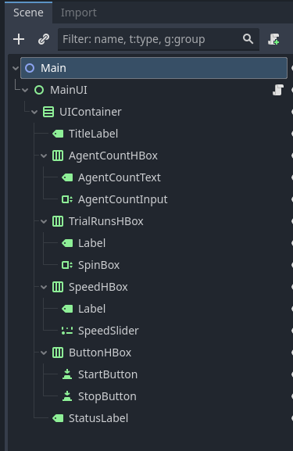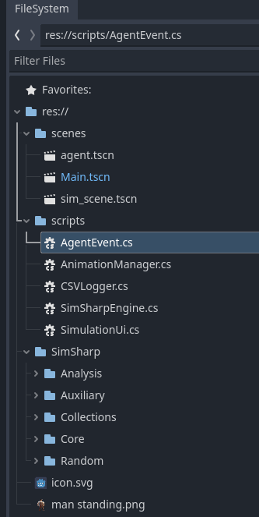
Figure: A1:Nodes from Main scene of GodotSim Figure A2: Scripts & integrated SimSharp folders
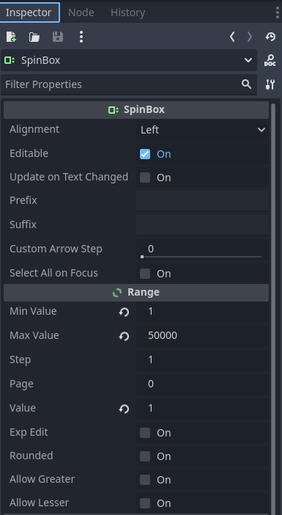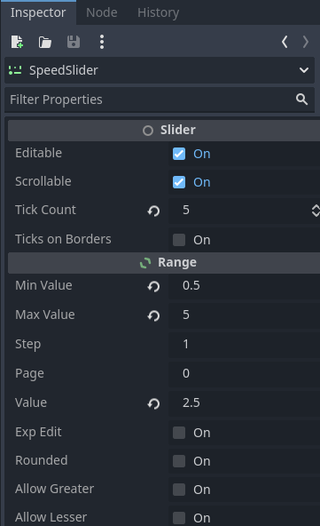

Figure A3 and Figure A4: Inspector Panel to set upper and lower limit values in control

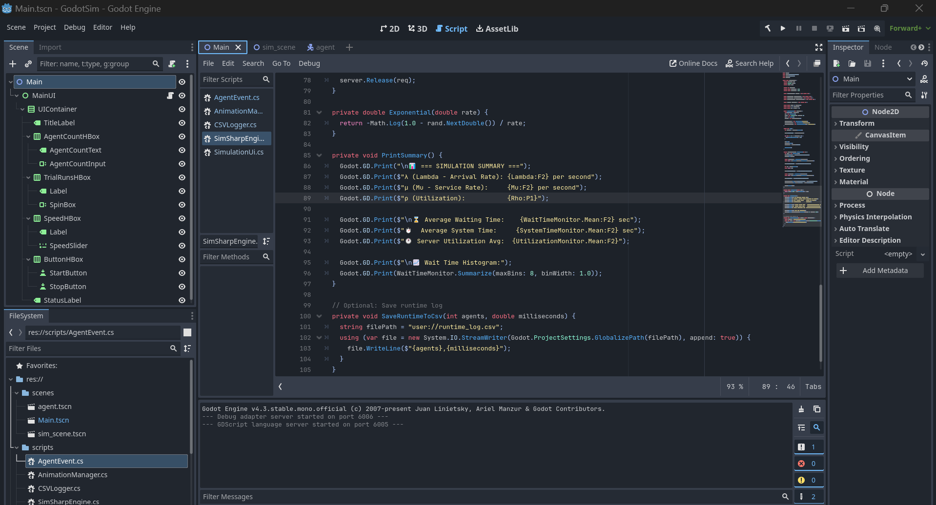

Figure A5: General Layout of Godot (Godotsim)
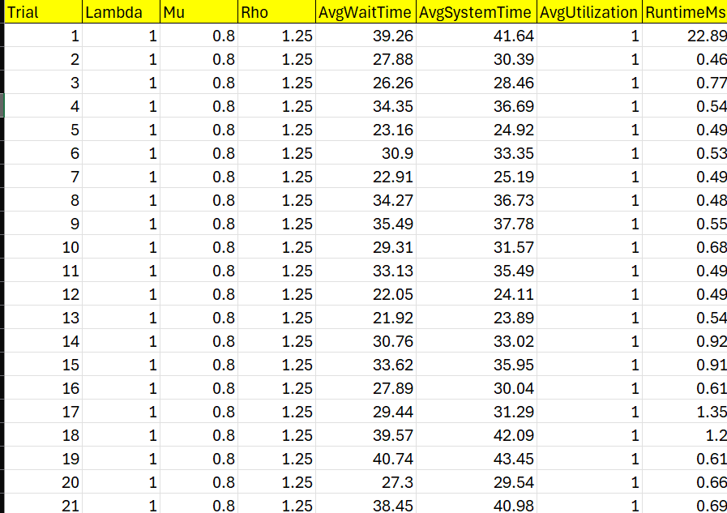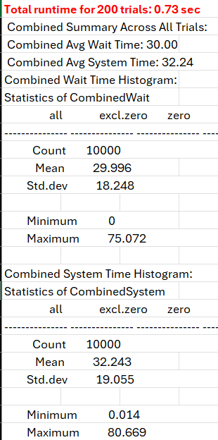

Figure A6: Output Summary after running simulation in Godotsim

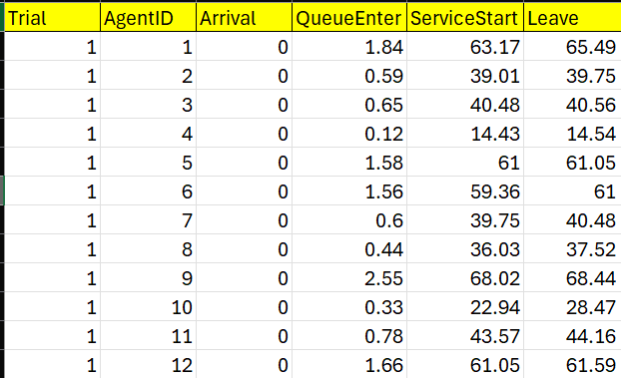

Figure A7:Event Output After running Simulation in Godotsim

